Translator Name:- Abdul Rahim Khan

Payment on Name:Munni Devi

Address:23B, JagatPuriColony Delhi-51

Ph. 9910171130

Date: 12/04/2024

GSTN : Not Applicable

**TAX INVOICE**

To,

To

Market Xcel Data Matrix

New Delhi

Invoice No: 02

Contact Person: Rupali/Rakhi Kashyap

Study Name:-MDZ 24 Carat India(20240206)

|  |  |  |
| --- | --- | --- |
| Sr. No. | Particular | Amount |
| 1.  2. | Translation of word QNR in 2 languages  Translation of PPT in 2 languages | 7600/-  400/- |
| **Total** | | **8,000/-** |
| SGST @ 9% | | **NA** |
| CGST @ 9% | | **NA** |
| Total | | 8,000/- |
| Advance | | **0** |
| Balance | |  |

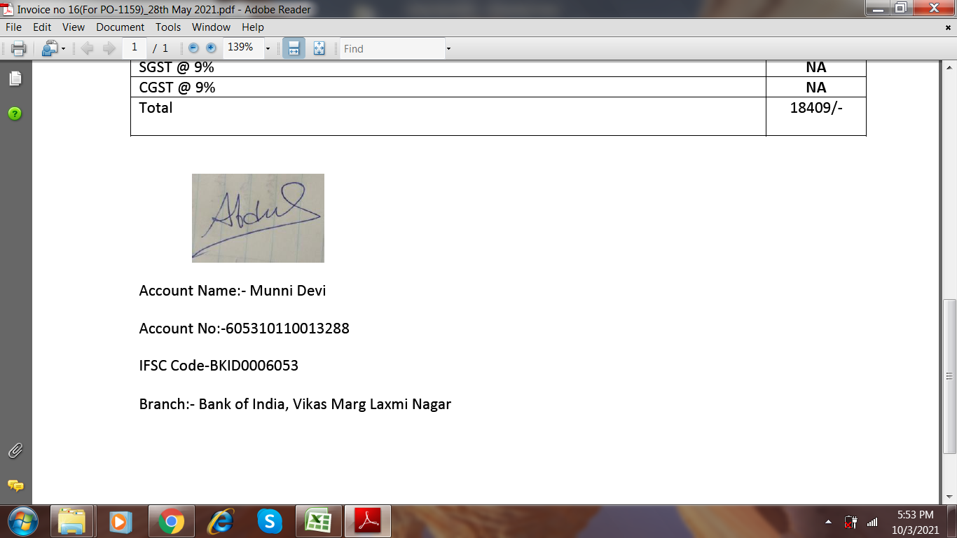

Account Name:- Munni Devi

Account No:- 605310110013288

IFSC Code-BKID0006053

Branch:- Bank of India, Vikas Marg Laxmi Nagar