INVOICE

Name - Surbhi kochar
Address: - 95 sai gangotri vihar, Indore 452002
Contact Details - +91 8109027770

Date: 17/05/2024
To,
Market Xcel Data Matrix Pvt Ltd.
Mumbai

Bill Number: 004
Project Name | Project Number | Details | Rate | Amount
Chocobakery biscuit | 20240532 | Moderation | 5000/- | 40000/-

Amount in words: forty thousand rupees Only/-
Bank details:-
Bank Acct #: - 20380803888
STATE BANK OF INDIA.
Name: - SURBHI SONI
IFSC: - SBIN0030015
Branch: - SBI BANK

For
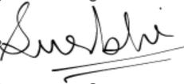
SURBHI SONI

