

Agency Briefing Document

Project: MDZ Oreo Wafer CAT IN

Agency: Market Xcel

**Contents**

Note: Press Ctrl and click on the row of the contents table to jump to that section of the brief

**Commissioning Brief – One Page Overview** 4

**Responsibilities** 6

**Methodology** 8

**Type of test** 8

**MMR briefing** 8

**COVID-19 Considerations at the venue** 8

**Recruitment & Sample** 9

**Recruitment method** 9

**Recruitment questionnaire** 9

**Consent Forms** 9

**Sample size** 9

**Sample criteria** 9

**Exclusion criteria** 9

**Quotas** 9

**Respondent numbering** 10

**Locations & Venues** 10

**Venue addresses** 10

**Fieldwork dates** 10

**Venue requirements** 10

**Session details** 10

**Room set up** 10

**Main Interview** 11

**Interview flow** 11

**Questionnaire rotations** 11

**Concept information** 11

**Concept codes** 11

**Concept assessment** 11

**Product information** 11

**Product delivery** 11

**Product codes and descriptions** 11

**Product storage** 12

**Product sourcing** 12

**Equipment sourcing** 12

**Photography** 12

**De-branding requirements** 13

**Leftover products** 13

**Product preparation & serving** 13

**Preparation** 13

**Serving** 14

**Photography** 14

**Data requirements** 14

**Data entry** 14

**Timings** 14

**Post Fieldwork** 14

**Appendix** 16

**1.** **Technical support for CAWI halls** 16

**2.** **Technical support for CAPI halls** 18

**3.** **MMR Escalation Procedure** 22

# **Commissioning Brief – One Page Overview**

Please note, all details contained within this brief are confidential and should be treated as such.

|  |  |
| --- | --- |
| *Project details* | |
| **Project Name** | MDZ Oreo Wafer CAT IN |
| **Project Number** | 318372 |
| **Project Description** | Prototypes testing against existing competitors. |
| **Repeat of a previous study?** |  |
| *Finance* | |
| **Agreed final cost (currency)** | 585,000 INR |
| **PO number** | IN200109 |
| *Contact details* | |
| **Main MMR Contact** | Leo ([L.Kunna@mmr-research.com](mailto:L.Kunna@mmr-research.com)), Sandeep ([s.budhiraja@mmr-research.com](mailto:s.budhiraja@mmr-research.com)) |
| **Alternative MMR Contact** | Priya ([p.bose@mmr-research.com](mailto:p.bose@mmr-research.com)) |
| *Type of test* | |
| **Methodology** | Sequential monadic CLT |
| **Recruitment method** | Pre-recruit |
| **Recruitment interview length** | 5 minutes |
| **Main Interview method** | Self-complete online survey |
| **Main Interview length** | 40 - 45 minutes |
| *Product information* | |
| **Number of products** | 8, 4 for each cell |
| **Number of concepts** | 1 |
| **Blind or Branded** | Blinded |
| *Sample* | |
| **Number of cells** | 2 |
| **Total end sample size** | N=300, 150 for each cell |
| **Sample definition (brief)** | * Mother of kids between age 9 – 14 years with their age 30 to 45 years * Kids : Boys and Girls (50: 50) * NCCA A and B * Regular consumers of wafer biscuit products. Have consumed a wafer biscuit in the last 2 times in a month   + Mix of brands – Britannia , Nebati (south) , Pickwick , Dukes, Unibic etc * Regular cream biscuit consumers – Mix Brand users Oreo , Sunfeast , Britannia Treat , Unibic |
| **Expected incidence of sample** | No |
| **Boost sample required** | No |
| **Expected incidence of boost** | No |
| *Locations & Venues* | |
| **Number of locations** | 2, Mumbai and Chennai |
| **Kitchen required?** | No |
| **Special equipment required?** | No |
| **Wifi / Internet required?** | Yes |
| **Will client or MMR visit?** | Yes, client and MMR |
| *Product preparation* | |
| **How are products stored?** | Dry at Ambient temperature |
| **How are products served?** | 2 pieces per product on a plate labelled with product codes |
| **Is product sourcing required?** | Yes |
| **Is de-branding required?** | Yes |
| *Key Timings* | |
| **Fieldwork dates** | 15 - 18 Oct |
| **Data delivery date** | 18 Oct |

# **Responsibilities**

|  |  |  |  |
| --- | --- | --- | --- |
| **Agency responsibility** | | ***Mark ‘X’ if applicable*** |  |
| **General:** | | | |
| Advise MMR of any crises or incidents in line with escalation appendix | | **X** |  |
| Agency to complete Contact details of project crisis manager (Name and telephone number): |  | | |
|  | | | |
| **Questionnaires:** | | | |
| Translating questionnaires | | **X** |  |
| Printing questionnaires | |  |  |
| Sense checking survey link | | **X** |  |
|  | | | |
| **Recruitment:** | | | |
| Preparing recruitment showcards | | **X** |  |
| Briefing fieldforce for recruitment | | **X** |  |
| Achieving respondent numbers requested | | **X** |  |
| Matching quotas and providing feedback to MMR during recruitment and fieldwork | | **X** |  |
| Ensuring respondents sign consent form(s) | | **X** |  |
| Screening respondents for allergies | | **X** |  |
| Respondents provided leaflet with agency/MMR contact details and information on the identifying symptoms of COVID-19 | | **X** |  |
|  | | | |
| **Product:** | | | |
| Take inventory of all product received and send to MMR | | **X** |  |
| Take photos of each product and send to MMR | | **X** |  |
| Send a set of products to MMR for review | | **X** |  |
|  | | | |
| **Fieldwork:** | | | |
| Hiring appropriate venues | | **X** |  |
| Organising a briefing session with project manager and MMR representative plus further briefings with supervisors and interviewers | | **X** |  |
| Matching recruitment and hall questionnaires using respondent numbers | | **X** |  |
| Re-checking recruitment criteria & re-screening for COVID-19 (Coronavirus) | | **X** |  |
| Couriering product/paperwork to venues | | **X** |  |
| Ensuring high standards of food hygiene are maintained throughout fieldwork | | **X** |  |
| Provision of interviewers/kitchen staff as required | | **X** |  |
| Providing palate cleansers | | **X** |  |
| Providing all equipment for the test | | **X** |  |
| Preparing and serving product according to instructions | | **X** |  |
| Screening the serving area from respondents | | **X** |  |
| Ensuring respondents sign consent form(s) | | **X** |  |
| Entering respondent recruitment data into the survey | | **X** |  |
| Payment of incentives | | **X** |  |
| Feedback fieldwork progress and quotas achieved to MMR | | **X** |  |
| Take photos of fieldwork in progress and send to MMR | | **X** |  |
|  | | | |
| **Post Fieldwork:** | | | |
| COVID-19 Reporting | | **X** |  |
| Editing questionnaires following MMR instructions | |  |  |
| Translating code frames | |  |  |
| Coding open end questions | |  |  |
| Photocopying all questionnaires | |  |  |
| Collating recruitment and main questionnaires for each respondent | | **X** |  |
| Couriering questionnaires to MMR by next day delivery with insurance | |  |  |
| Return spare product to <MMR / Client> | | **X** | TBD |

# **Methodology**

## **Type of test**

Blind CLT, ~45 minutes per respondent

## **MMR briefing**

No fieldwork should begin until a briefing has been given.

* An Online brief between MMR and Market Xcel will take place on 14 Oct, 11:00 am. This is your opportunity to ask any questions to make sure you understand the brief.

**COVID-19 (Coronavirus) considerations:**

* All staff and visitors to fieldwork (MMR and/or end clients) are to complete a ‘Heath & Contacts Declaration Form – Staff and Clients’ to self-declare they are COVID-19 free.
  + Completed forms to be retained for at least 2 months
* Where possible, arrangements should be made for remote viewing of the fieldwork to allow clients to view fieldwork without attending in person. Skype or other options should be discussed with the MMR team at the earliest opportunity.
* All participants MUST be re-screened using the ‘Heath & Contacts Declaration Form – Consumers’ to self-declare they are COVID-19 free.
  + Completed forms to be retained for at least 2 months
* After re-screening, all participants are to wash their hands using soap & water or hand sanitizer. The agency will be responsible for sourcing soap/hand sanitizer.
* Consumers must be instructed at recruitment to bring a suitable face covering with them which they will need to wear at all times, other than when they are sat at their desk/table.  Venue staff must wear face coverings at all times. If a consumer, member of staff or visitor forgets to bring one they should be offered a disposable one or may be asked to leave; if they refuse to wear one they may be asked to leave the venue.
* All staff are to regularly wash hands throughout the fieldwork.
* All surfaces should be cleaned using a suitable anti-bacteria or alcohol based formula or wipes after every session
* Space people as recommended/mandated by your government. Use desk dividers wherever possible.
* Minimize congregations of people (e.g. waiting areas) by staggering session start times or by any other means practical.
* Again, if culturally acceptable AND fieldwork taking place in a country/region with cases of COVID-19 (Coronavirus) MMR and the agency are to discuss the testing of participants temperature on arrival using a contactless temperature gauge. These are to be purchased and users familiarised with their operation in advance of fieldwork. If possible ensure that a spare device is made available as well as spare batteries etc) .
* If the agency has any problems sourcing any of the equipment detailed above, they are to raise this with MMR at the earliest opportunity.

This short WHO video should be shared with all staff in advance of attending fieldwork

<https://youtu.be/1APwq1df6Mw>

# **Recruitment & Sample**

## **Recruitment method**

5-10 minutes pre-recruit

## **Recruitment questionnaire**

All respondents recruited must meet the specified criteria and be eligible for the test. The recruitment questionnaire gives clear routing to follow and instructions of when to terminate the interview.

The respondent must be made aware of what the test involves and must agree to take part.

## **Consent Forms**

All participants must sign the informed consent form prior to beginning fieldwork. Forms and paper questionnaire should be stored securely for 2 years following fieldwork.

## **Sample size**

Split sample equally across cells:

* Total main sample size: n=300
  + Total cell 1 sample size: n=150
  + Total cell 2 sample size: n=150

## **Sample criteria**

All respondents must:

* Mother of kids between age 9 – 14 years with their age 30 to 45 years
* Kids : Boys and Girls (50: 50)
* NCCA A and B
* Regular consumers of wafer biscuit products. Have consumed a wafer biscuit in the last 2 times in a month
  + Mix of brands – Britannia, Nebati (south) , Pickwick , Dukes, Unibic etc
* Regular cream biscuit consumers – Mix Brand users Oreo , Sunfeast , Britannia Treat , Unibic

## **Exclusion criteria**

Interviewers must make sure respondents are not allergic to any of the test product ingredients and respondents must sign the respondent declaration to confirm this.

In addition, respondents must not:

* Reject of chocolate/cocoa/vanilla flavor.
* Reject of Oreo , Britannia & Nebati brand

## **Quotas**

Split quotas equally across locations:

|  |  |  |
| --- | --- | --- |
| **Quota** | | **% to be achieved** |
| **Gender of Kid** | Male | 50 |
| Female | 50 |
| **Location** | Mumbai | 50 |
| Chennai | 50 |
| **Socio-Economic Class** | A | 50 |
| B | 50 |

## **Respondent numbering**

* Respondent numbering should start from 1001 **(or 11001 / 21001 etc if using the new ID sheet macro in the RP)**
* Allocate a number to the respondent and write it on the front page of their recruitment and main questionnaires

|  |  |
| --- | --- |
| **Area** | **Begins…** |
| Mumbai | 1001 |
| Chennai | 2001 |

Allocate each respondent to a unique USERID

* Use each USERID only once

# **Locations & Venues**

## **Venue addresses**

Agency to complete

## **Fieldwork dates**

Mumbai - 14-17 Oct

Chennai - 15-18 Oct

## 

## **Venue requirements**

|  |  |
| --- | --- |
| **Number of rooms per venue** | Depends on the venue |
| **Internet / Wi-Fi requirements** | Yes |
| **Preparation / Serving area** | Yes |
| **Kitchen requirements** | No |
| **Kitchen appliances needed** | No |
| **Other room requirements** | Storage room |

## **Session details**

Agency to complete

|  |  |
| --- | --- |
| **Number of testing days per venue** |  |
| **Set-up start time each day** |  |
| **Testing day start and end time** |  |
| **Number of sessions per day** |  |
| **Length of each session** |  |
| **Number of respondents per session** |  |

## **Room set up**

The room should be set up as follows:

* Respondents seating must be arranged so that they cannot see each other’s test
* Preparation and serving area must be fully screened
* Print out the concept text, laminate it and put it on the table so the respondent can read it.

At the end of each session tidy up, replenish water and palate cleansers and remove all used products and paperwork, ready for the next session to begin.

# **Main Interview**

## **Interview flow**

1. Respondents (both mother and kid) arrive at the venue, check in
2. Respondents wash their hands
3. Interviewer leads them to their seats
4. Per product code, serve 2 sticks – one for mother and one for the kid
5. Respondent takes water as palate cleanser while interviewer’s getting the 1st product tested
6. Respondent consumes the first product
7. Interviewer to instruct respondent not to eat the entire product – they must leave some for appearance/aroma/flavour questions as and when asked on the screen
8. Then answers the questions on 1st Product
9. Interviewer to explain respondent briefly the options of JAR question
10. 2 mins break and they consume water and unsalted cracker for palate cleansing
11. Then they taste the second product and answer questions for the second product
12. Once first 2 products are tried, ask the preference question between them
13. Similar steps for 3rd & 4th products
14. Once all 4 products are tried, Show concept now – concept as print out (laminated) and also on screen
15. please serve 1 stick of the products to mother again and please ask Q25-28 only for prototypes (Cell 1- 511/321 and Cell 2 – 952/737) – instruction shown on screen as well

## **Questionnaire rotations**

There are 8 rotations. The order of products is shown within the survey, follow on screen instructions.

|  |  |  |  |  |  |
| --- | --- | --- | --- | --- | --- |
| Cell 1 | Rotation | 1st product | 2nd product | 3rd product | 4th product |
| 1 | 511 | 867 | 321 | 256 |
| 2 | 867 | 511 | 256 | 321 |
| 3 | 321 | 256 | 511 | 867 |
| 4 | 256 | 321 | 867 | 511 |

|  |  |  |  |  |  |
| --- | --- | --- | --- | --- | --- |
| Cell 2 | Rotation | 1st product | 2nd product | 3rd product | 4th product |
| 5 | 952 | 433 | 737 | 179 |
| 6 | 433 | 952 | 179 | 737 |
| 7 | 737 | 179 | 952 | 433 |
| 8 | 179 | 737 | 433 | 952 |

# **Concept information**

## **Concept codes**

|  |  |  |
| --- | --- | --- |
| **Concept name** | **Code** | **Format and number to print** |
| Oreo Wafer |  |  |

## **Concept assessment**

* Respondent will test the prototype then the concept will be shown and few questions ask about it.
* Print out the concept text, laminate it and put it on the table so the respondent can read it. Please keep it upside down so the respondents don’t see it before they have to

# **Product information**

## **Product delivery**

Products ready for pick up for Mumbai at TTC – 12 Oct

Products shipped to Chennai and reach location by 14Oct

You must check and count all products upon delivery and send an inventory to MMR as soon as possible.

## 

## **Product codes and descriptions**

|  |  |  |  |
| --- | --- | --- | --- |
|  |  | Name | Product Code |
| Cell 1 | Pair 1 | Prototype 1 | 511 |
| Britannia | 867 |
| Pair 2 | Prototype 2 | 321 |
| Britannia | 256 |

|  |  |  |  |
| --- | --- | --- | --- |
|  |  | Name | Product Code |
| Cell 2 | Pair 1 | Prototype 1 | 952 |
| Nabati | 433 |
| Pair 2 | Prototype 2 | 737 |
| Nabati | 179 |

## **Product storage**

Dry at Ambient temperature

## **Product sourcing**

You must source:

|  |  |  |
| --- | --- | --- |
| **Product name** | **Amount to source** | **Details / Image** |
| Britannia | Enough for fieldwork | Britannia chocolate – 60 gm – Rs 25 SKU |
| Nabati | Enough for fieldwork | Nabati chocolate – 35 gm – Rs 10 SKU |

All products should be sourced by 12 Oct and stored as follows:

* Dry at ambient temperature

## **Equipment sourcing**

You must source:

|  |  |  |
| --- | --- | --- |
| **Equipment** | **Amount to source** | **Details / Image (if necessary)** |
| Bottled Water | Enough to use | Unbranded |
| Paper Plate | Enough to use | Label the plate with product code |
| Palate cleanser – Unsalted cracker | Enough to use |  |

All equipment must be sourced by 9 Oct.

## **Photography**

Please take photos of

* Product packs

## **De-branding requirements**

Cover serving section

## **Leftover products**

TBD

# **Product preparation & serving**

You may want to copy the following instructions into a separate document for use by servers during fieldwork.

Food safety standards should be met at all times; gloves and hairnets should be worn when preparing and serving food products.

## **Preparation**

* Please label paper plate based on product code / put 1 pieces per product on the plate for each assessment.

Do not serve the samples if

* The wafer sample is broken
* One of the wafer sheet is half broken
* Crocodile effect : the wafer sticks have opened up like a crocodile mouth and not stuck to each other
* Cream spread on outer wafer etc
* If consumer complains that the sample is soggy , kindly check the pack , if you perceive sogginess too discard the sample and give another one to consumer

Furthermore, there’s some specific details on some products:

One of the prototypes is in pack as below. The product serving team will need to be careful with this pack once opened, kindly put silver foil to close the ack after serving and put this in zip lock bag every time please, otherwise wafer will catch moisture.  You can call this as “Indonesia sample”



The second sample is as below. You can call this “Gandour sample” this is packed in individual perk packs, so should not be a concern on catching moisture.

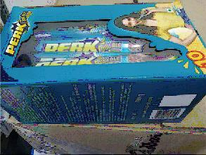

## **Serving**

* Serve 1 piece per product to each respondent
* Serve on the paper plate
* Please label the plate with product code

## **Photography**

* Fieldwork venues
* Preparation rooms
* Respondents testing the products

# **Data requirements**

## **Data entry**

Recruitment data must be entered at the end of the survey by an interviewer. Follow on screen instructions.

# **Timings**

|  |  |  |
| --- | --- | --- |
| **Stage** | **Deadline** | **Notes** |
| Fieldwork | 14 - 18 Oct |  |
| Data Delivery | 18 Oct |  |

# **Post Fieldwork**

Completed COVID-19 Health and Contacts Declaration forms must be retained for at least 2 months

# **Appendix**

## **Technical support for CAWI halls**

If you have problems at a CAWI CLT (Computer Assisted Web Interview – Central Location Test) please follow these steps:

1. First, check the **Common Problems** listed below, as it will help you to identify what is wrong so you can fix it or describe it better to the support team.

* **Cannot connect to the survey at all**

Try going to [www.bbc.co.uk](http://www.bbc.co.uk) or [www.cnn.com](http://www.cnn.com) to test if you can connect to the internet.

* + If you can, there is a problem with the survey.
  + If you cannot, it could be a problem with your laptops/tablets/WiFi/router – this is not something we can help you with – you need to contact your IT support at your location.
* **Can connect to the survey, but passwords are not working**

Double check you are using the correct list of Respondent IDs and passwords.

* If you are, the list uploaded into the survey might be different to the list given to you – contact support and ask them to read out some Respondent IDs and Passwords to check.
* They can export the uploaded list of IDs and passwords and email you the correct list.
* Or in extreme cases they could change the passwords to match the IDs, just while we sort out a better solution.
* **Survey is working, but one of our fancy (Flash) drag and drop question tools is not working**

Sometimes the survey works OK but gets stuck at the first fancy (Flash) question

* If this happens for every computer in the room, the question may not be programmed correctly. Contact support and describe the question very carefully so they can fix it.
* Otherwise it might be that the computers do not have Flash installed, which would have to be fixed locally using [www.get.adobe.com/flashplayer](http://www.get.adobe.com/flashplayer)
* **General issues within the survey**

If a question is wrong, or a spelling mistake, or the wrong question appears, or the wrong image/stimulus material, please check that the Respondent has not clicked the “Back Button” either on the survey screen (as there should not be one) or in the Browser toolbar. Try to replicate the problem and describe exactly what steps you took, to support.

1. Next, try to email the Survey Programming Team as they may be online. Use the Group address [SurveyProgrammingTeam@mmr-research.com](mailto:SurveyProgrammingTeam@mmr-research.com) to contact the whole team.
2. Or call:(UK) Survey Programming Team +44 (0)1491 824999 (Normal hours 09:00 to 17:30 GMT)
3. If there is no response within 5 minutes you should try contacting our E2E Support Team in India…

* You must send the email to the group email, Swarn and Yogesh as well as the Survey Programming team at MMR (using the address above). If you don’t get a response use the phone numbers below:

Group email [mmrgroup@e2eresearch.com](mailto:mmrgroup@e2eresearch.com)

Yogesh [Yogesh.rana@e2eresearch.com](mailto:Yogesh.rana@e2eresearch.com) (+91 98 11 356 560)

Manoj [Manoj.rana@e2eresearch.com](mailto:Manoj.rana@e2eresearch.com) (+91 9811356560)

* Note that E2E Support will not have access to MMR drives (stimulus or files) so you will need to email these files if necessary. E2E can see the survey, can check what data has been recorded, can see which logins have been used, can fix passwords or upload a new respondent list and things like that.

1. If it is outside standard UK office working hours, and your survey has been programmed by Rigour, please:
   * Take a screen shot of the issue and email it to your Rigour programming contact
   * Contact Rigour on the following number: **+44 (0)2088964525** or email them at[MMR-support@rigourresearch.com](mailto:MMR-support@rigourresearch.com). *Please allow the phone to ring 15-20 times as the call is diverted through a number of extensions before it reaches the final recipient (give them enough time to answer the call)*
   * **These communication routes should only be used when there is a serious issue at the hall which is preventing respondents successfully completing the survey and only after all the usual checks have already been completed**

## **Technical support for CAPI halls**

**Notes for agency**

* **Inform MMR of number of licences required**

Please inform the MMR project team at the earliest opportunity as to how many MMR CAPI licences will be required (how many ‘seats’ per day and on which days) – this will allow us to ensure licences are booked in advance and the running of fieldwork remains unaffected.

* **Use one device per Interviewer log in**

Interviewers must use the same device throughout fieldwork (inc. for fieldwork running over separate days). Failure to do so could result in data loss and/or being locked out of your device and losing fieldwork time.

**We suggest labelling devices and making a note of which device each Interviewer is using.**

* **Share names of all devices used with MMR**

See “how to find console name” instructions at the end of this document. This includes all devices that have been used for testing, regardless of whether they’re used in live fieldwork.

Please remember: these interviews are conducted **offline**, so data collected by an interviewer will be stored on their specific device **only**.

They will not be able to access their user IDs or data on any other device.

**Technical Support**

If you have problems during a CAPI interview please follow these steps:

* First make sure the device used is supported
* For iOS, all devices iOS 9+. Properly tested on iPhone, iPad/mini, OS9 and 10.
* For Android, all devices OS 4.1+, on both tablets and mobiles.
* Then check out the **Common Problems** listed below, as it will help you to identify what is wrong so you can fix it or describe it better to the support team.
* Next, try emailing the Data Sciences Team as they may be online. Use [SurveyProgrammingTeam@mmr-research.com](mailto:SurveyProgrammingTeam@mmr-research.com) to contact the whole team.
* Or call:
* (UK) Data Sciences Team +44 (0)1491824999 (Normal hours 09:00 to 17:30 GMT)
* (Cali) Data Sciences Team +57 (2)3920505 (Normal hours 08:00 to 16:00 GMT-5)

**Common Problems**

**Can connect to the survey, but user information is not correct**

Double check you are using the correct list of Respondent IDs. If you are, the list uploaded into the survey might be different to the list given to you – contact support and ask them to read out some Respondent IDs to check. They can export the uploaded list of IDs and email you the correct list.

**Survey is working, but one of our ‘fancy’ question tools is not working**

Sometimes the survey works ok but gets stuck at a tool/exercise – if this happens for every device, the question may not be programmed correctly. Contact Support and describe the question as carefully as possible so they can fix it.

**General issues within the survey**

If a question is wrong, there is a spelling mistake, the wrong question appears, or the wrong image/stimulus material, try to replicate the problem and describe exactly what steps you took, to Support. Screenshots would be ideal if possible.

**Cannot sync data**

Usually this means the internet connection is not adequate. Do NOT uninstall the CAPI app at any point as it may result in data loss. Try syncing again using a wifi connection. If you are still having problems, please contact Support Team.

**How to Install and Use CAPI**

1. On a Tablet or Mobile phone, download the “Confirmit CAPI” app
2. Activate the device: Open the App, press “Site” and choose “UK”, then type the Activation code (this will be sent over via email before fieldwork starts), then press activate.

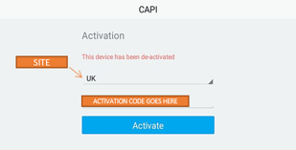

1. You will see the login page, type the username and password given by MMR.

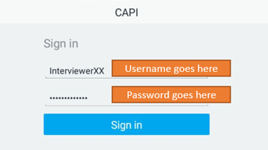

1. Wait until the survey downloads and enter (tick the project name).

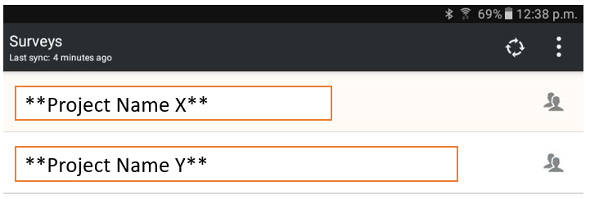

1. Go to Respondents tab to make sure all respondents associated with your interviewer ID are shown. Then choose any respondent to get started - your device should be on airplane mode.

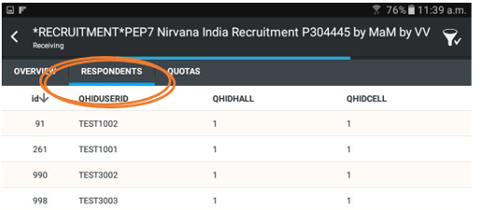

1. Once you are finished with interviews.
   1. Connect to Internet
   2. Synchronize data back to us by tapping the “Refresh” icon

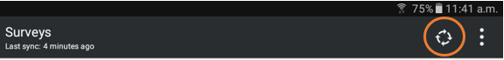

* 1. Make Sure respondents data was sent to us: enter the respondents tab (see step 5). The respondent ID will be removed from the list on your device once it’s synced successfully.

**How to find the console name**

1. Tap on the 3 vertical dots
2. Then Settings

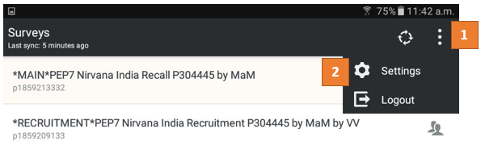

1. Then let us know which Console it is, it will be: "MMR Ltd" followed by a number

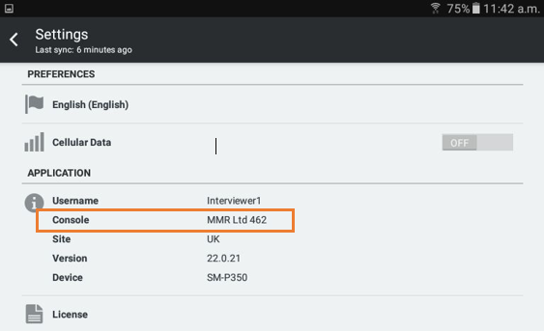

## **MMR Escalation Procedure**

1. **Introduction**

This document describes the minimum requirements for managing significant incidents and crises (as described below). In accepting awarded Projects from the Company, the Supplier agrees to work in accordance with the Company’s escalation procedure as set out below.

1. **Definitions**

**2.1** A **crisis** is defined as follows:

* A significant interruption to service continuity and/or
* Significant barriers to delivering project work for MMR and/or
* A risk of the involvement of media, authorities or other governing bodies

Including, but not limited to, natural disasters, food safety breaches, terrorism (including larger scale data breaches / cyber-attacks), coups, political activism, fire or burglary leading to loss of product or data.

A crisis represents a threat to:

* People (Company employees including those of third parties, members of the public); and/or
* The business of the Company or its end client (financial situation, operations, reputation); and/or
* The environment.

**2.2** An **incident** is an event that:

* Interrupts normal operations but with limited impact on people and/or the business and/or the environment and/or
* Can be resolved within normal day-to-day operation but requires urgent action

Including, but not limited to, failure in achieving daily progress for key study criteria (such as recruitment criteria, adherence to rotation plans, any aspect of project scheduling), breach of data protection guidelines or legislation, blind product recognition, missing or damaged inventory, equipment malfunctions.

1. **Escalation and action**

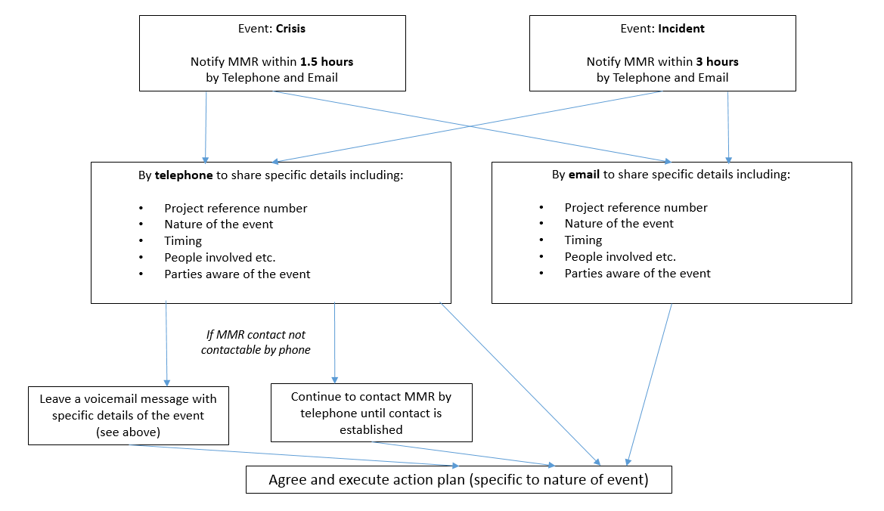

Note: The Supplier (nor its sub-contractors) should not make any public communication about work, brands or companies without consent in writing from a MMR Director-level employee.