Lubna Shaikh

Fatima Villa Behind Sterling Apt Church Road Marol Andheri East

Mumbai 400059

Tel :7039006060/9987666664

Date: 18/04/2024

To,

Market Xcel Data Matrix Pvt Ltd.

111 Royal Enclaves,1st Floor

Parsi Panchayat Road,

Andheri East Mumbai 4000-69

Bill Number :004

|  |  |  |  |  |
| --- | --- | --- | --- | --- |
| Project Name | Project Number | Details | Rate | Amount |
| Toothbrush | 20240390 | 3grp | 3000 | 3000/- |
|  |  |  |  |  |
| Conveyance |  |  | 200 | 200 |

Amount in words:Three Thousand and two hundred only.

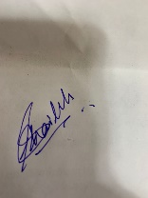

Lubna Shaikh



7039006060

Bank Acct #  :-007899000002238

Bank Yes Bank Pvt Ltd

Name :- Lubna Faizuddin Shaikh

IFSC :- YESB0000078

Branch :- Marol