BILL OF SUPPLY
(GST NON- REGISTER)

VENDOR NAME  VENDOR ADDRESS  VENDOR MOBILE NO  VENDOR PAN NO  VENDOR E-MAIL ID | SRINI N  2-2-647/77/G25 SBI OFFICERS COLONY; HYDERABAD, TELANGANA STATE, HYD-13  7989096677  BSXPN8885L  SRININALAMATI1998@GMAIL.COM
INVOICE DATE – 29/3/2024  JOB NAME- STARTUPS  JOB NUMBER- 20230798 |  | BILLING TO,  SHAMAAIL FATMA

S. NO. | DESCRIPTION | IDI/  FGD/  MGD/  WORKSHOP | ACTIVITY/  UNIT/  QTY/  MINS | PER UNIT RATE (RS.) | TOTAL AMOUNT (RS.)
- Moderation  - Conveyance |  |  |  |  | 1500
 |  |  |  |  | 500
 | TOTAL |  |  |  | 2000

TOTAL IN WORDS: TWO THOUSAND ONLY

BENEFICIARY NAME: - SRINI N
BANK NAME: - CANARA BANK
BANK ACCOUNT NO.: - 6725101000598
BANK ACCOUNT TYPE: - SAVINGS ACCOUNT
BANK IFSC CODE: - CNRB0006725
BANK BRANCH ADDS: - DD COLONY, HYDERABAD
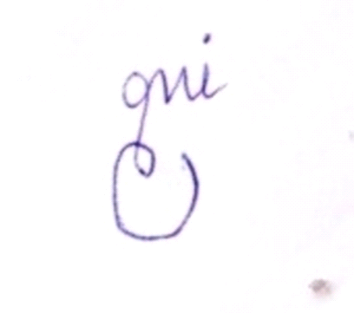
(SIGNATURE)

