# Markets: India

**Consumer Profile; n= 32/ market**

**Total 12 markets – N= 384**

* Age: 18-60 yr. old; M/F 50:50
* Living in rural communities
* Consumers and or non rejectors of Health Supplements like multi vitamins, OTC products (like pain relief, cold flu tablets, paracetamol etc.
* Standard exclusions for market research (e.g., non to be working in associated professions and related consumer health care companies, non to have participated in similar research/ survey in past one year)

|  |  |  |
| --- | --- | --- |
| **Respondent Details** | |  |
| Name of respondent |  |
| Mobile number (Mandatory) |  |
| Address |  |
| State (Drop down code list) |  |
| District (Drop down code list) |  |
| Block Name |  |
| Village Name |  |
| Pin code  **GPS Mandatory** |  |  |

|  |  |  |
| --- | --- | --- |
| **Other Details** | |  |
| Name of Interviewer |  |
| Name of Supervisor |  |
| Date and Time of Interview |  |

|  |
| --- |
| **Introduction** |
| Introduction: Good morning / afternoon / evening.  My name is ______________________ from Market Xcel, an established market research agency. Currently, we are conducting a market research survey to understand the health literacy in rural India. We would really appreciate if you could spare some time and provide us with your valuable inputs for our current study.  Please be assured we are not selling you anything, we are only interested in your opinion. May I ask you a few questions? |

Q.a. Please indicate your age in completed number of years. Record age in completed years.

________ (Record the verbatim)

Post code in the grid below

|  |  |  |
| --- | --- | --- |
| Age | Code |  |
| Less than 18 years | 1 | Terminate |
| 18– 20years | 2 | Continue |
| 21-30 years | 3 | Continue |
| 31-40 years | 4 | Continue |
| 41-50 years | 5 | Continue |
| 51-60 years | 6 | Continue |
| More than 60 years | 7 | Terminate |

Q.b. Please select your gender? **SA**

|  |  |
| --- | --- |
| Gender | Code |
| Male | 1 |
| Female | 2 |

Q.c. Do you or any of your family members works in the following Industries? **SA**

|  |  |  |
| --- | --- | --- |
| ORGANIZATION | CODE |  |
| Advertising agency / Market research / Mass media | 1 | Terminate |
| Health care companies | 2 |
| Medicines manufacturing companies | 3 |
| Other healthcare related work | 4 |
| None of the above | 99 | Continue |

Q.d. Have you participated in similar or any other healthcare related survey in past 1 year? **SA**

|  |  |  |
| --- | --- | --- |
|  | Code | Instruction |
| Yes | 1 | Terminate |
| No | 2 | Continue |

Q.1. Please indicate all of the Over-The-Counter medication that you:

**Select the right response for each of the rows. SA**

|  |  |  |  |
| --- | --- | --- | --- |
| Answer Options | Used in the past 3 months | Have used but not in the past 3 months | Have not used but I am open to use it |
| Fever |  |  |  |
| Cold and cough |  |  |  |
| Diarrhea / digestive issues |  |  |  |
| Pain |  |  |  |
| Weakness |  |  |  |
| Tiredness / fatigue / dizziness |  |  |  |
| Heart health issues |  |  |  |
| Kidney / liver health issues |  |  |  |
| Cuts / burns |  |  |  |
| Eye health issues |  |  |  |
| Others, please specify |  |  |  |

Q.2. Out of this following list, which one do you do to get relief from health issues? **MULTIPLE RESPONSE**

|  |  |
| --- | --- |
| **Items** | **Code** |
| Exercising | 1 |
| Use herbal remedies | 2 |
| Eat healthy food | 3 |
| Home remedies | 4 |
| Only take rest | 5 |
| Take medicines based on earlier treatment | 6 |
| Take medicines from chemist | 7 |
| Take medicine / consultation from doctor/ RMP / Other health providers | 8 |
| Take consultation from ASHA/ ANM / AWW | 9 |
| Others, please specify | 10 |

Q.3. Please indicate all the health supplements that you consume/ will consumer:

|  |  |  |  |
| --- | --- | --- | --- |
| Answer Options | Have consumed in the past 3 months | Have consumed but not in the past 3 months | Have not consumed but open to it |
| Multivitamins (e.g., tablet, soft gels, capsules, gummies, syrups) |  |  |  |
| Single vitamin supplements (e.g., Vitamin C, Vitamin A, Vitamin D etc.) |  |  |  |
| Omega-3 Supplements (e.g., DHA, EPA, Fish Oil) |  |  |  |
| Mineral tablets/ capsules (Iron, Magnesium etc.) |  |  |  |
| Probiotics |  |  |  |
| Bone Joint Health Supplements |  |  |  |
| Digestive and Gut Health Supplements |  |  |  |
| Ayurvedic and Herbal Supplements |  |  |  |
| Other health supplements to support immunity of the body (Please specify) |  |  |  |

Q.4. Which of the following Over-The-Counter products have you purchased in the past 3 months? **[MA]**



|  |  |
| --- | --- |
| Answer options - **RANDOMIZE** |  |
| Crocin | 1 |
| Vicks | 2 |
| Nasivion | 3 |
| Easibreathe | 4 |
| Dabur | 5 |
| Otrivin | 6 |
| Himalaya | 7 |
| Vaporin | 8 |
| Zandu | 9 |
| Tiger Balm | 10 |
| Patanjali | 11 |
| Iodex | 12 |
| Mama Earth | 13 |
| Sensur | 14 |
| Amrutanjan | 15 |
| Others (Please Specify) | Open-Ended |
| None, I did not purchase any Over-The-Counter products in the past 3 months | **EXCLUSIVE** |

Q.5. Which of the following health supplements have you purchased in the past 3 months? **[MA]**

|  |  |
| --- | --- |
| Answer options - **RANDOMIZE** |  |
| Becadexamin | 1 |
| Becosules | 2 |
| Becozyme C Forte | 3 |
| Zincovit | 4 |
| Revital | 5 |
| Neu Herbs | 6 |
| Supradyn | 7 |
| Cipcal | 8 |
| Ostocalcium | 9 |
| Shelcal | 10 |
| HK Vitals | 11 |
| Lymcee | 12 |
| Centrum | 13 |
| GNC | 14 |
| Others (Please Specify) | Open-Ended |
| None, I did not purchase any health supplements products in the past 3 months | **EXCLUSIVE** |



Q.6. Please select the right option for each one of the attributes regarding your health management.

|  |  |  |  |  |  |
| --- | --- | --- | --- | --- | --- |
|  | 5-Point Rating Scale | | | | |
| Always (5) | Often (4) | Sometimes (3) | Occasionally (2) | Never (1) |
| **1. Actively Managing Health** |  |  |  |  |  |
| 1) I set my own goals about health and fitness | 5 | 4 | 3 | 2 | 1 |
| 2) There are things that I do regularly to be healthy | 5 | 4 | 3 | 2 | 1 |
| 3) I eat a balanced, healthy diet | 5 | 4 | 3 | 2 | 1 |
| 4) I engage in actions to prevent illness | 5 | 4 | 3 | 2 | 1 |
| **2. Confidence and skills to find and access information** |  |  |  |  |  |
| 1) I know where to find reliable and accurate  health information | 5 | 4 | 3 | 2 | 1 |
| 2) I am able to find information about health and  health problems when I need it | 5 | 4 | 3 | 2 | 1 |
| 3) I am able to get health information in words I  understand | 5 | 4 | 3 | 2 | 1 |
| 4) I am able to get health information by myself | 5 | 4 | 3 | 2 | 1 |
| **3. Confidence and skills to appraise health information** |  |  |  |  |  |
| 1) I am able to accurately identify symptoms and  follow health advice | 5 | 4 | 3 | 2 | 1 |
| 2) I am able to understand health information | 5 | 4 | 3 | 2 | 1 |
| 3) I have clear understanding even if different sources have different information about the  same health topic | 5 | 4 | 3 | 2 | 1 |
| 4) I feel confident using the health information to  manage my own health and self-manageable conditions | 5 | 4 | 3 | 2 | 1 |
| 5) I feel confident to understand and follow the  instructions on pack | 5 | 4 | 3 | 2 | 1 |
| **4. Support from social circle** |  |  |  |  |  |
| 1) I have family and friends who can give me useful advice on health so that I can confidently self-  manage my health | 5 | 4 | 3 | 2 | 1 |
| **5. Support from healthcare providers and system** |  |  |  |  |  |
| 1) I am able to access the right healthcare support whenever I need to ( **e.g clinics, hospitals)** | 5 | 4 | 3 | 2 | 1 |

|  |  |  |  |  |  |
| --- | --- | --- | --- | --- | --- |
| 2) I have at least one healthcare provider who I can trust and go to for advice/seek treatment (e.g  doctors, pharmacists) | 5 | 4 | 3 | 2 | 1 |

Q.7. Which of the following conditions do you feel confident managing by yourself (without seeking advice/treatment from pharmacist/doctor/GP)? **[MA]**

* + Multiple select from:
    - colds, coughs
    - headache
    - body pain
    - sore throat
    - fever
    - diarrhea
    - indigestion
    - constipation
    - back ache
    - period pain
    - earache
    - None, I do not feel confident managing any conditions above by myself **[EXCLUSIVE]**

Q.8. Did the pandemic change your attitude to self-management of your health? **[SA]**

* Yes
* No

Q.9. Did the pandemic change your attitude to accessing healthcare services? **[SA]**

* Yes
* No

Q.10. Right now (**in 2023**), out of 100% of the time when you need to treat your illnesses/conditions, how frequently do you…. *(Please enter from 0-100, total must add up to 100)* **[OE]**

|  |  |
| --- | --- |
| **[RANDOMIZE]** | Out of 100% of the time  *(Total add up to 100)* |
| Take care of yourself **as first option** |  |
| Seek advice from pharmacist **as first option** |  |
| Seek advice/treatment from doctor/ GP.  **as first option** |  |

Q.11. Before COVID-19 pandemic (**in 2019**), out of 100% of the time when you needed to treat your illnesses/conditions, how frequently did you…. *(Please enter numerical from 0-100, total must add up to 100)* **[OE]**

|  |  |
| --- | --- |
| **[RANDOMIZE]** | Out of 100% of the time  *(total add up to 100)* |
| Took care of yourself **as first option** |  |
| Sought advice from pharmacist **as first option** |  |
| Sought advice/treatment from doctor/ GP **as first option** |  |

Q.12. Thinking of Immunity- Which of the following topics will you be interested in? **[MA]**

* + Food that can boost your immunity
  + Daily activities to boost your immunity
  + How the immune system works
  + How multivitamins support your immunity
  + Improving immunity in elderly
  + Building your kids’ immunity
  + Others (*Define )*

Q.13. Understanding of overall pain management *(1-not at all aware, 2-slightly aware, 3-moderately aware, 4-very aware, 5-extremely aware)* **[SA]***:*

|  |  |  |  |  |  |
| --- | --- | --- | --- | --- | --- |
|  | *1* | *2* | *3* | *4* | *5* |
| I know what causes pain. | ☐ | ☐ | ☐ | ☐ | ☐ |
| I know how to effectively manage different types of pain. | ☐ | ☐ | ☐ | ☐ | ☐ |

Q.14.a. From the stimuli shown here, select each medication and indicate how familiar you are with each one.

- **Allow respondents to select options (paracetamol, ibuprofen, topical diclofenac) directly from the stimuli before letting them rate how familiar they are with each of them**

|  |  |  |  |
| --- | --- | --- | --- |
|  | 1- Not at all familiar | 2- Somewhat  familiar | 3- Very Familiar |
| **Paracetamol** |  |  |  |
| **Ibuprofen** |  |  |  |
| **Topical Diclofenac** |  |  |  |

Q.14.b. Please indicate your opinion on these brands from the following options.

|  |  |  |
| --- | --- | --- |
|  | **“I’d like to know more information”** | **“I have enough information”** |
| **Paracetamol** |  |  |
| **Ibuprofen** |  |  |
| **Topical Diclofenac** |  |  |

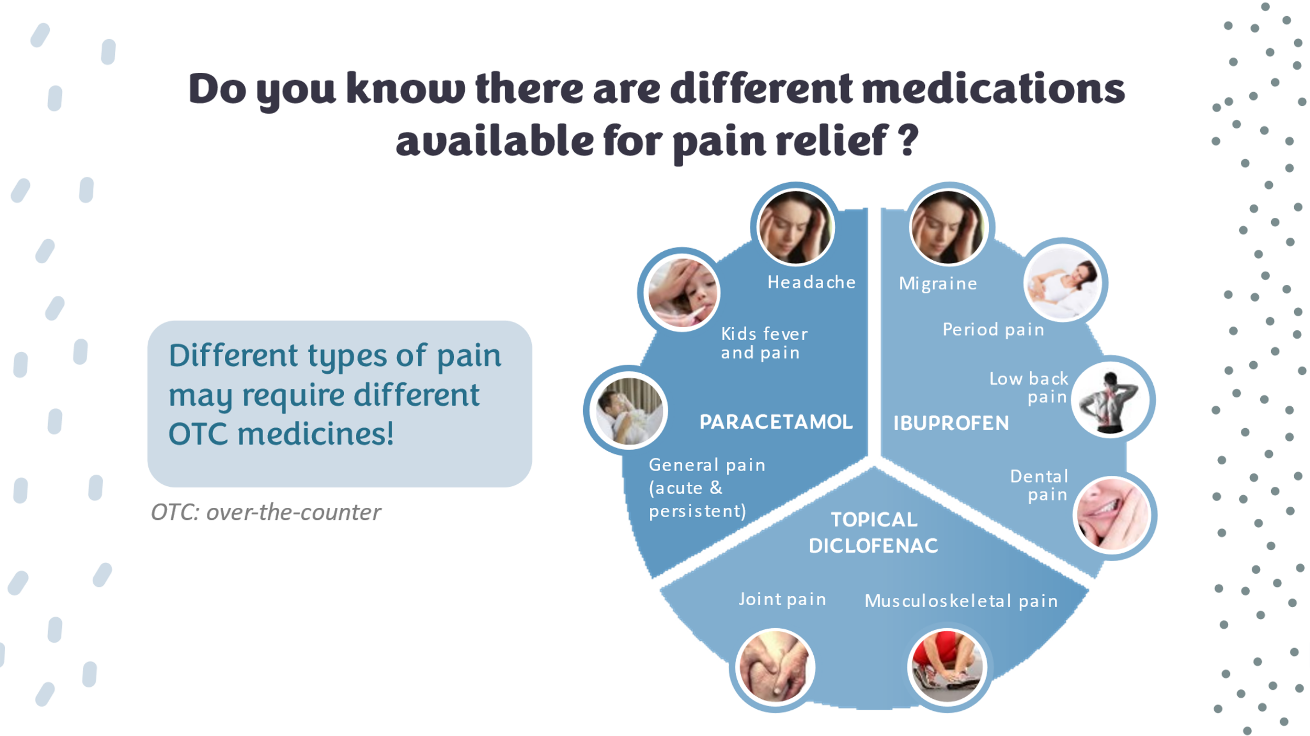**Show this stimuli for Q.14**

Q.15. Which are the top 5 sources of information that helped you feel confident about self-managing the ailments or your health in general? **[MA]** *Please select up to 5. Please rank these sources from ‘1’ being the ‘most frequent’.*

**Online content**

* + 1. YouTube
    2. Social media (e.g., Instagram, Facebook, TikTok, etc.)
    3. Branded company websites
    4. Non-branded websites
    5. Product reviews **Offline content**
    6. Print advertisements/ flyer
    7. Product pack label
    8. In-store display
    9. Information provided by doctors
    10. Information provided by salesperson/pharmacist

**Others**

* + 1. Word-of-mouth
    2. Radio or TV advertisement
    3. Others (*Define )*

Q.16. Which are the considerations you make when purchasing health & OTC products? **[MA]**

* + - 1. Ingredients
      2. Warnings
      3. Recommendation by doctors/ pharmacists/ influencers
      4. Recommendation by family/ friends
      5. Dosage form
      6. How the product works
      7. Brand name
      8. Company name
      9. Others *(Define )*

Q.17 Looking at the product information on pack, what information do you find helpful in using the product .**[MA]**

**(show stimuli)**

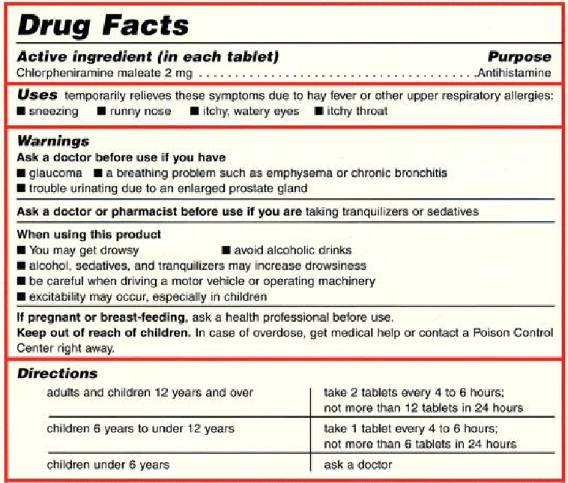

|  |  |
| --- | --- |
| Product composition | 1 |
| Dose | 2 |
| Use/ indications | 3 |
| Method of use | 4 |
| Contra-indications (information about conditions or other | 5 |
| drugs which may make this product risky to take) | 6 |
| Warning/ precautions | 7 |
| Side effects | 8 |
| Storage conditions | 9 |
| Something else (*specify )* | 98 |