|  |  |  |  |  |  |  |  |  |  |
| --- | --- | --- | --- | --- | --- | --- | --- | --- | --- |
| **Date** | 22 March 2024 | **Version** | | V1 | **Copy of this FBN to be sent to DA , PPH & QC** | | | | |
| **NAME OF THE PROJECT** | | | Candy Boosters | | | **Job no#** | J2.007426.02 | | |
| **HH or Non HH** | | | NHH/HH | | | **Product Category** | Confectionery | | |
| **Adhoc / Track** | | | Adhoc | | | **If Track (Total Number .of wave):** | | |  |
| **CAPI / PAPI** | | | CAPI | | | **If Track (mention frequency of wave )** | | |  |
| **RPM Executive In charge** | | |  | | | **RPM Manager** | | Kaushal Sharma | |
| **CSTSS Executive In charge** | | |  | | | **CIPD Manager** | |  | |
| **CS Executive In charge** | | | Ruchi Sinha | | | **CS Manager** | | Shikha Mittal | |

**OBJECTIVE AND BACKGROUND OF THE STUDY:**

**RESEARCH OBJECTIVE:**

**To gauge the usage & non usage of few High value/ multi value packs of selected brands of confectionery.**

**To find out consumption of subcategories & brands –**

To understand consumption, frequency of usage and purchase of the sub-categories and various brands in them

**Triggers & Barriers –**

Reasons of using/ not using / not trying of the brand from their Users, Lapsers and ANT”s

**Understanding Consumption Behavior –**

Understand the 5 Ws and 1 H of consumption

WHO, WHEN, WHERE, WHAT, WHY, HOW

***UNDERSTANDING CONFECTIONARY ITEMS:***

HERE Confectionery would mean “Toffees, Candies, Lollipops, Chewing Gum, Bubble Gums, Eclairs, Jellies, soothing candies, Digestive candies, mints/refreshment candies, etc.”

It does not include cakes, biscuits, or puddings which require cutlery to consume. It doesn’t include chocolates.

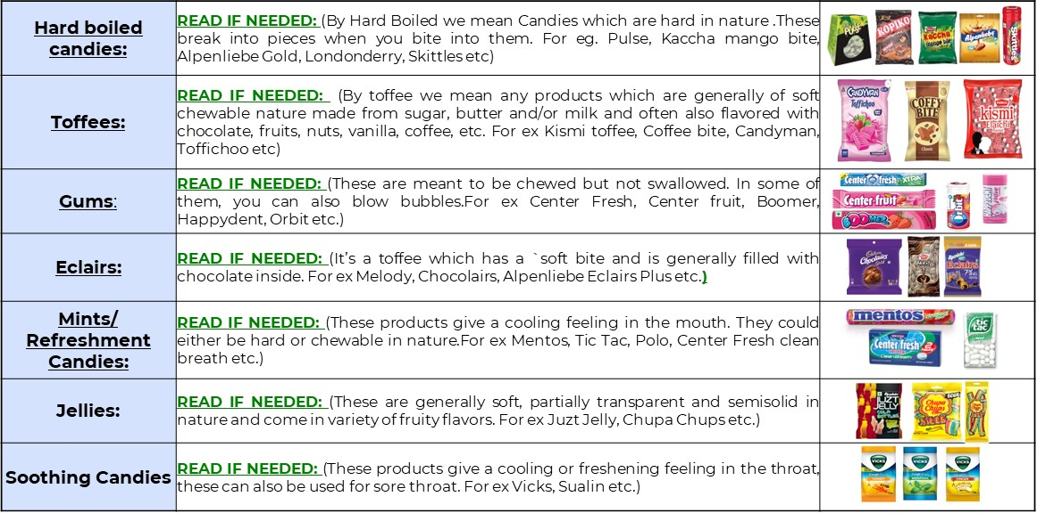

|  |  |  |
| --- | --- | --- |
| **Target Respondent Profile – (Mention target respondent PROFILE and also include THE DEFINITION and respective question numbers from the final link or q’re.)** | | |
| **Particulars** | **Details** | **Reference Q. No** |
| **Gender** | Male and Female | Q10 |
| **Age Group** | 8 to 35 Years | Q10.2 |
| **SEC** | NCCS A/B | Q9.1 |
| **Usage Criteria** | Consumed Confectionary in last 7 days | Q14 |
| **Centers** | Delhi/ Mumbai/ Hyderabad/ Kolkata | Q3 |

| **Basic Details of the study** | |
| --- | --- |
| **Starting points to be picked up through Random Sampling or Purposive?** | Purposive |
| **Random Sampling unit will be electoral roll / Voter or polling booth list?** | NA |
| **Right Hand Rule ( RHR) to be followed within Starting points ( SP) ( Yes / No)** | No |
| **Zonal spread of starting points to be maintained or natural fall out as per sampling :** | No |
| **If sampling unit is Polling Booth from where the first HH will be knocked? (**   * The HH falls right hand side of the polling booth * HH which is at the nearest xing of the road or lane of polling booth | NA |
| **If sampling unit is area purposive from where the first HH will be knocked?**   1. Once you reach the area look for the mid-point of that area. Slight here & there is ok. 2. Once you reach the mid-point , HH which is at the nearest xing of the road or lane of mid-point |  |
| **Contacts to be maintained in each SP? ( Yes / No)** | No |
| **Area Summary sheet / General Contact sheets to be maintained? ( Yes / No)** | No |
| **Contacts to be given any serial number? ( Yes / No)** | YES |
| **If Area Summary sheet / General Contact sheets needs to be maintained, needs to be dispatched? ( Yes / No)** | No |
| **Listings: If there is any Fixed number of listings in each SP? (Yes / No)** | YES, 4-5 |
| **Listings: If there is any maximum number of listings in each SP? ( Yes / No)** | YES, 5-6 |
| **Listings: Which is non-qualifying for main to be given any serial number by SP ? ( Yes / No)** | NA |
| **Listings: Which is non-qualifying for main to be maintained & dispatched? ( Yes / No)** | NA |
| **Main / Detail Interview: If there is any maximum number of Main / Detail Interview in each SP? ( Yes / No)** | Yes, max 6 interviews in a SP |
| **LOI Listing** | NA |
| **LOI Main** | 45 min |
| **Is there any skipping ? ( Yes / No)** | Yes |
| **If Yes for Skipping , then is it after valid listing or valid main ?** | Main |
| **If Yes for Skipping , Number of HH needs to be skipped** | 2 |
| **Kish Grid to be followed? ( Yes / No)** | No |
| **For Kish Grid , which serial number to be followed , Listing or Main/Detail** | NA |
| **If any quota? If yes please mention in the grid below. ( Yes / No)** | No |
| **Quota to be maintained center wise or state wise or zone wise?** | NA |
| **Concept Test : Number of concepts** | NA |
| **Concept Test : Number visit** | NA |
| **Define working days a week and Non-working a week – If Applicable** | All days |

| **Team Composition** | |
| --- | --- |
| **If any tele callers required?** | NO |
| **Profile of the interviewer?** | HH |
| **Gender of the interviewer? Male / Female / Mix** | Mix |
| **Any additional checker is required?** | Yes |

| **FW Materials / Schedule** | **Frequency / Schedule / date / Remarks** |
| --- | --- |
| Final translated live link or Q’re |  |
| Images or videos folder if applicable | NA |
| OE Link | NA |
| Translated Show cards | Yes |
| Translated OE sheets | NA |
| Budget | NA |
| LOI calculator |  |
| Concept |  |
| Stimulus | NA |
| Photo cards | NA |
| Who will print Concept / stimulus / Photo cards | NA |
| Concept / Stimulus / Photocard : To be returned ? | NA |
| Show Cards | NA |
| Products | NA |
| Tele calling script | NA |
| Database by centers and segments if any | NA |
| Quota sheet |  |
| Contact sheet | NA |
| Others (please specify) |  |

|  |  |
| --- | --- |
| Early Warning Note ( EWN) Sent On | - |
| Date of field briefing to EIC’s |  |
| Briefing /Mock calls of Freelancers - *(In case of lengthy and complex qnnr it is mandatory to provide one additional day for training / mock calls)* |  |
| Date of team briefing : ( should be a gap of one day post sharing of Final material) |  |
| Date of Mock call : |  |
| Fieldwork Start Date: ( should be a gap of one day post Mock call) |  |
| Fieldwork End Date: |  |
| First Sync / Dispatch |  |
| Final CE data to be synchronized on / Dispatch to be done on |  |
| Final OE entry to be done |  |
| Confirmation on QC complete by Field Team |  |
| Confirmation on QC complete by IQC team |  |
| Final CE Data to CRDC/GO |  |
| Final OE Data to CRDC/GO |  |

|  |  |
| --- | --- |
| Frequency of Synchronization of interview (if CAPI) | Alternate |
| Frequency of OE Entry & Synchronization (if CAPI) | Alternate |
| Frequency of Status update ( If CAPI) | Everyday by PMT |
| Frequency of Status update (if PAPI) | NA |
| Frequency of Dispatch (if PAPI) | NA |
| Dispatches to be sent to ? Name & Office | NA |
| Feedback Qre to be sent to Name & Office | NA |
| Feedback qre to be sent within number of days of launching? | NA |
| Date of launch of each centre to be confirmed ( Yes / No) | Yes |

|  |
| --- |
| **Additional Remarks (If any)** |

* FW Methodology – Purposive
* Interviews can be conducted via door-to-door/ near market places/ bakery shops/ wholesale shops via CAPI
* We will be regularly checking the proportion of Age, gender, NCCS, covered in each brand regularly.
* Quotas to be regularly monitored.
* During the main interview, interviewer to ensure that all instructions are followed, and all the responses are recorded correctly
* Data will be reviewed at 30%, 60% and 90% completion
* In case of any concerns please raise issues in the beginning and not at the end of the study
* Penetration of Confectionary in general is very high, which should be kept in mind during fieldwork
* Penetration of the brands covered is low which should also be taken into account.