**Food Infant Cereal Study-EWN**

Objective of the study: -This research will encompass some critical category dynamics for Infant cereal and brand KPIs. Revised, upgraded brand communications for HCP specifically addressing their barriers in prescribing the brand.

Type of study: - Adhoc (Database study)

Interview method: F2F and self-administered.

Target Group: - Pediatricians (> 90% of sample) and neonatologists Mix of practice sitting (private clinic, hospital, nursing home etc.)3-30 years of practice Should be a recommender of Infant Cereal brands.

Sampling method: Database

Estimated Fieldwork duration: - 3 Weeks.

Sample Plan: -

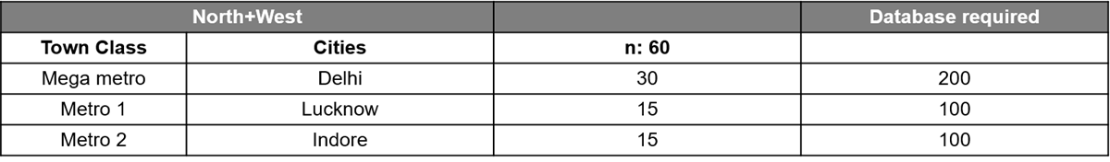

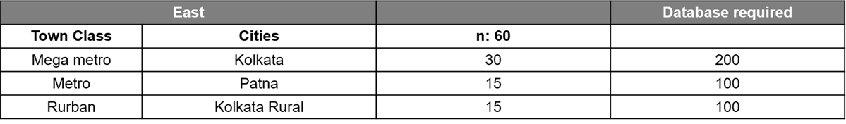

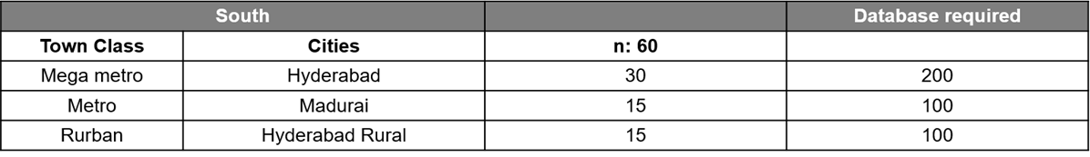

Field briefing: - 7th March.

Fieldwork starts: - 7th March.

Fieldwork End: - 22nd March.