Hi Anant,

All the suggested changes has been incorporated. A briefing of the team is happening today and the field will roll from tomorrow onwards.

Thanks & Regards

**Prasenjit Saha**

Project Director



**Market Xcel Data Matrix Pvt. Ltd.**

Extension: 551 / Direct Line: +91 11 42343 551 / Mobile: +91 9899765200

***Follow us on***

[](https://www.facebook.com/marketxceldatamatrix)  [](https://twitter.com/marketxcel)  [](https://www.linkedin.com/company/market-xcel-data-matrix-pvt-ltd?trk=tyah)

**From:** Anant Badhe <[abadhe@yamaha-motor-india.com](mailto:abadhe@yamaha-motor-india.com)>   
**Sent:** 24 November 2022 09:20  
**To:** [prasenjit@market-xcel.com](mailto:prasenjit@market-xcel.com)  
**Cc:** [chandana.banerji@market-xcel.com](mailto:chandana.banerji@market-xcel.com); 'Vikram Gupta' <[vikram.gupta@market-xcel.com](mailto:vikram.gupta@market-xcel.com)>; [manish.ganvir@market-xcel.com](mailto:manish.ganvir@market-xcel.com); P.Nanda Kumar <[pnkumar@yamaha-motor-india.com](mailto:pnkumar@yamaha-motor-india.com)>  
**Subject:** RE: Request for proposal - Study of The Call Of The Blue campaign

Dear Prasenjit,

Please share the progress.

Regards  
Anant

**From:** Anant Badhe   
**Sent:** Tuesday, November 22, 2022 12:06 PM  
**To:** [prasenjit@market-xcel.com](mailto:prasenjit@market-xcel.com)  
**Cc:** [chandana.banerji@market-xcel.com](mailto:chandana.banerji@market-xcel.com); 'Vikram Gupta' <[vikram.gupta@market-xcel.com](mailto:vikram.gupta@market-xcel.com)>; [manish.ganvir@market-xcel.com](mailto:manish.ganvir@market-xcel.com); P.Nanda Kumar <[pnkumar@yamaha-motor-india.com](mailto:pnkumar@yamaha-motor-india.com)>  
**Subject:** RE: Request for proposal - Study of The Call Of The Blue campaign

Dear Prasenjit,

Thank you for sharing the link.

Please find below the feedback:

1. Change the introduction—Bank?

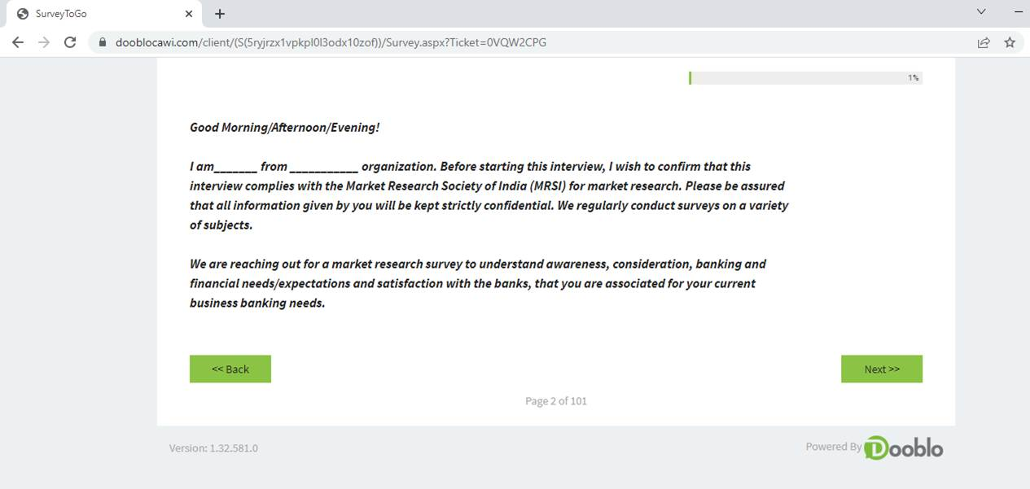

1. Could not understand the below :

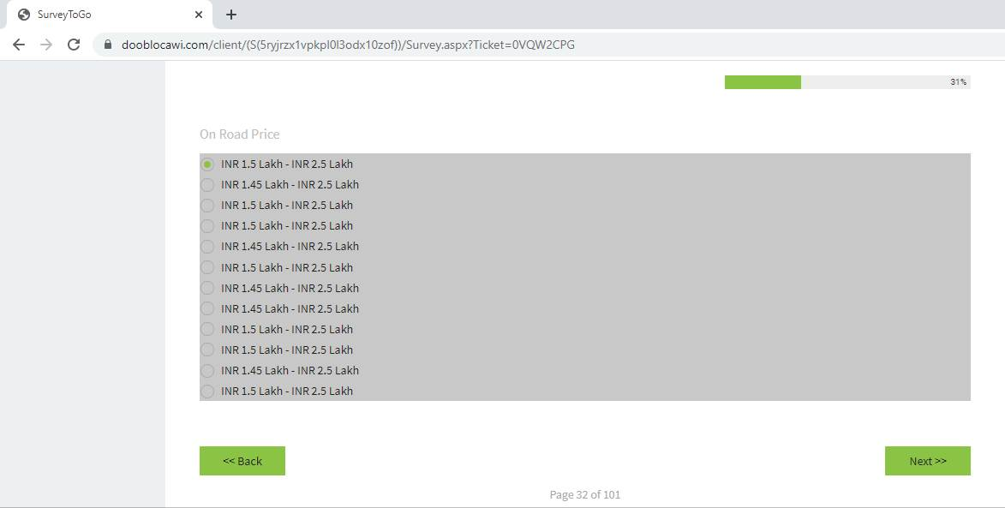

1. Please randomize the options sequence in the below question:

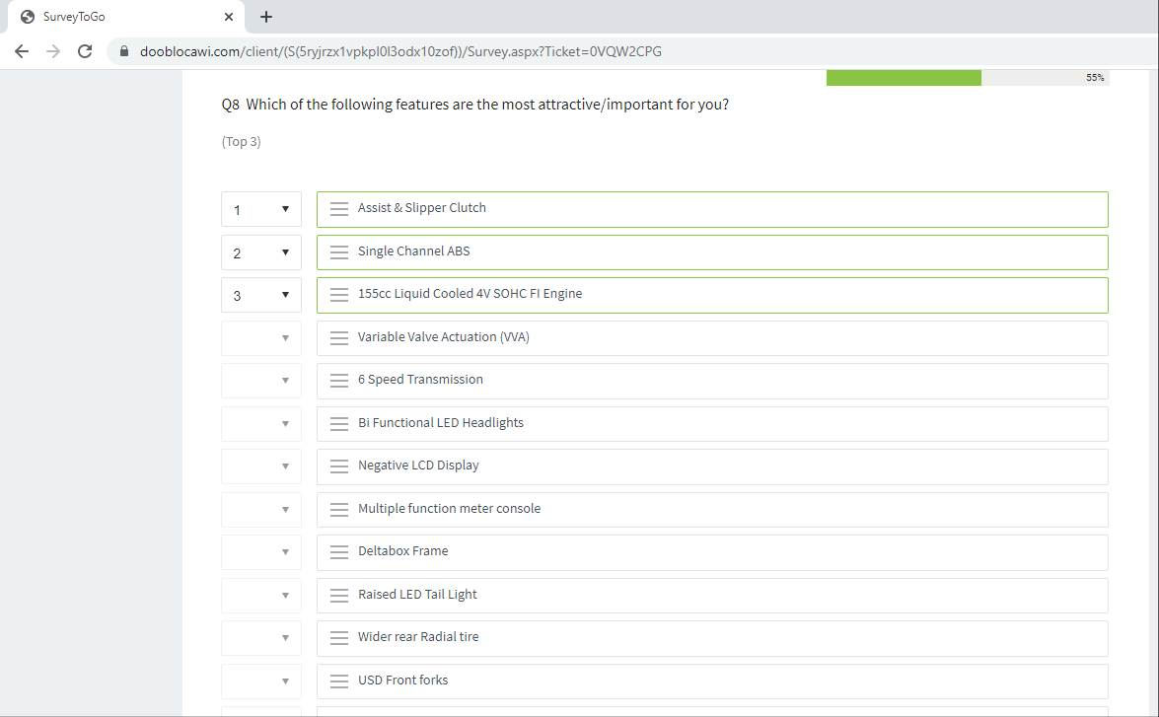

1. Need to ask this question to individual model selected same for F,G,H, 10-2

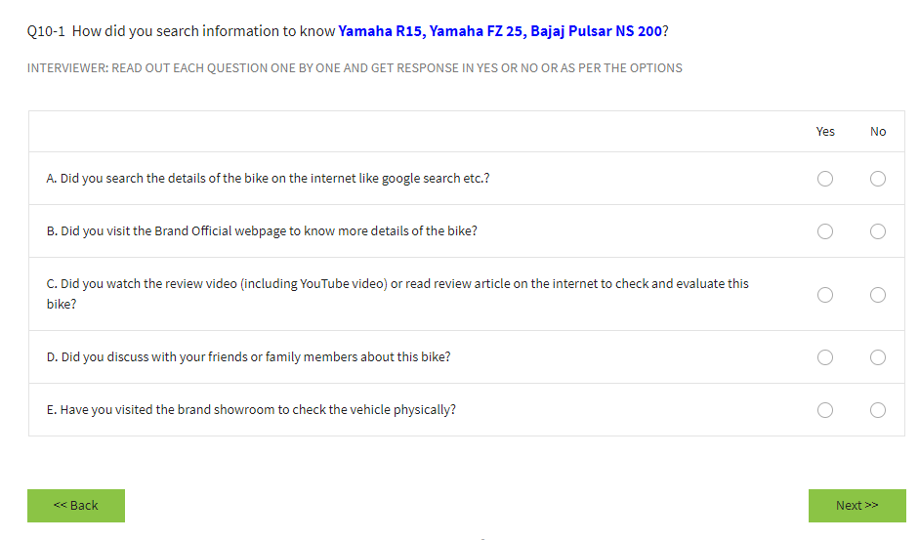

Rephrase the question – remove “How”

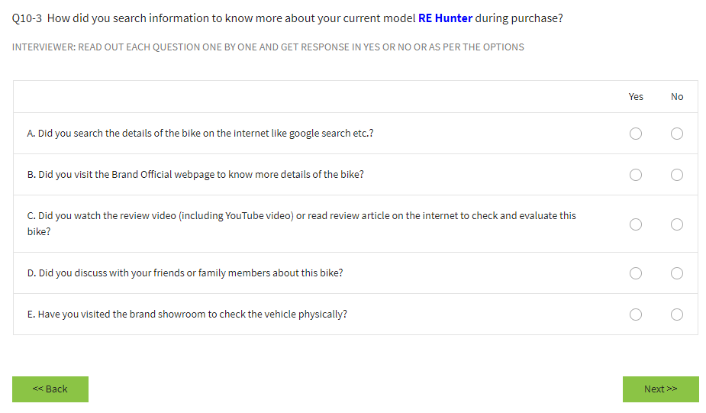

Post selection of “no” in Q11, In Q11-1 if engine performance was poor , please ask further 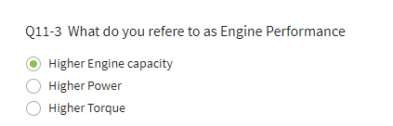

The following section is missing:

|  |  |  |  |  |
| --- | --- | --- | --- | --- |
| **Q14** | **SA** |  | **Did you consider Royal Enfield Hunter during purchase of your bike** | **Ask all except Hunter Owner** |
|  |  | 1 | Yes |  |
|  |  | 2 | No |  |
|  |  |  |  |  |
| **Q14-1** | **Ma** |  | **Why did you consider Royal Enfield Hunter during the purchase journey** | **Ask if coded '1' in Q14** |
|  |  | 1 | Latest launch |  |
|  |  | 2 | Light weight |  |
|  |  | 3 | Manufacturer Brand |  |
|  |  | 4 | Manuevarability |  |
|  |  | 5 | Price |  |
|  |  | 6 | Riding comfort |  |
|  |  | 7 | High engine capacity |  |
|  |  | 8 | color & graphics |  |
|  |  | 9 | Sepcial Finance Scheme |  |
|  |  | 10 | Others (Specify) |  |
|  |  | 11 | Design |  |
|  |  | 12 | Style |  |
|  |  |  |  |  |
| **Q14-2** | **MA** |  | **Why did you reject Royal Enfield Hunter during the purchase journey** | **Ask if coded '1' in Q14** |
|  |  | 1 | Non Availability (Long waiting time) |  |
|  |  | 2 | Riding Posture |  |
|  |  | 3 | Heavy weight |  |
|  |  | 4 | Old Style |  |
|  |  | 5 | Color & graphics |  |
|  |  | 6 | Others (Specify) |  |

Please make the changes and share the link for rreview

Regards  
Anant

**From:** Prasenjit Saha <[prasenjit@market-xcel.com](mailto:prasenjit@market-xcel.com)>   
**Sent:** Monday, November 21, 2022 2:27 PM  
**To:** Anant Badhe <[abadhe@yamaha-motor-india.com](mailto:abadhe@yamaha-motor-india.com)>  
**Cc:** [chandana.banerji@market-xcel.com](mailto:chandana.banerji@market-xcel.com); 'Vikram Gupta' <[vikram.gupta@market-xcel.com](mailto:vikram.gupta@market-xcel.com)>; [manish.ganvir@market-xcel.com](mailto:manish.ganvir@market-xcel.com); P.Nanda Kumar <[pnkumar@yamaha-motor-india.com](mailto:pnkumar@yamaha-motor-india.com)>  
**Subject:** RE: Request for proposal - Study of The Call Of The Blue campaign

Hi Anant,

Please find below the programming link for the same –

[https://www.dooblocawi.com/client/Survey.aspx?Ticket=0VQW2CPG](https://jpn01.safelinks.protection.outlook.com/?url=https%3A%2F%2Fwww.dooblocawi.com%2Fclient%2FSurvey.aspx%3FTicket%3D0VQW2CPG&data=05%7C01%7Cabadhe%40yamaha-motor-india.com%7C49d9158e8a5949cf6b3f08dacb9e2574%7C76684a67d81643ce93f929b6f72f823f%7C1%7C0%7C638046177399350039%7CUnknown%7CTWFpbGZsb3d8eyJWIjoiMC4wLjAwMDAiLCJQIjoiV2luMzIiLCJBTiI6Ik1haWwiLCJXVCI6Mn0%3D%7C3000%7C%7C%7C&sdata=0yrDVxX75z2ze9GcT1AJm%2F9lbTBGn1FLFI4i%2BuPRS%2BU%3D&reserved=0)

Thanks & Regards

**Prasenjit Saha**

Project Director



**Market Xcel Data Matrix Pvt. Ltd.**

Extension: 551 / Direct Line: +91 11 42343 551 / Mobile: +91 9899765200

***Follow us on***

[](https://jpn01.safelinks.protection.outlook.com/?url=https%3A%2F%2Fwww.facebook.com%2Fmarketxceldatamatrix&data=05%7C01%7Cabadhe%40yamaha-motor-india.com%7C49d9158e8a5949cf6b3f08dacb9e2574%7C76684a67d81643ce93f929b6f72f823f%7C1%7C0%7C638046177399350039%7CUnknown%7CTWFpbGZsb3d8eyJWIjoiMC4wLjAwMDAiLCJQIjoiV2luMzIiLCJBTiI6Ik1haWwiLCJXVCI6Mn0%3D%7C3000%7C%7C%7C&sdata=UpqnwBrVgv3rmNxUNMVIUk42npWJp1WFzvvX8byk7NA%3D&reserved=0)  [](https://jpn01.safelinks.protection.outlook.com/?url=https%3A%2F%2Ftwitter.com%2Fmarketxcel&data=05%7C01%7Cabadhe%40yamaha-motor-india.com%7C49d9158e8a5949cf6b3f08dacb9e2574%7C76684a67d81643ce93f929b6f72f823f%7C1%7C0%7C638046177399350039%7CUnknown%7CTWFpbGZsb3d8eyJWIjoiMC4wLjAwMDAiLCJQIjoiV2luMzIiLCJBTiI6Ik1haWwiLCJXVCI6Mn0%3D%7C3000%7C%7C%7C&sdata=K8PEWk8QpnkXuRN%2B%2Feqpp2d1qJ3J2ozVhXwuoFrwGkg%3D&reserved=0)  [](https://jpn01.safelinks.protection.outlook.com/?url=https%3A%2F%2Fwww.linkedin.com%2Fcompany%2Fmarket-xcel-data-matrix-pvt-ltd%3Ftrk%3Dtyah&data=05%7C01%7Cabadhe%40yamaha-motor-india.com%7C49d9158e8a5949cf6b3f08dacb9e2574%7C76684a67d81643ce93f929b6f72f823f%7C1%7C0%7C638046177399506288%7CUnknown%7CTWFpbGZsb3d8eyJWIjoiMC4wLjAwMDAiLCJQIjoiV2luMzIiLCJBTiI6Ik1haWwiLCJXVCI6Mn0%3D%7C3000%7C%7C%7C&sdata=GwIQ0bmYXbLnFalpNlWR30bkR1t46M2DhdeysfWZYCk%3D&reserved=0)

**From:** Prasenjit Saha <[prasenjit@market-xcel.com](mailto:prasenjit@market-xcel.com)>   
**Sent:** 21 November 2022 10:38  
**To:** 'Anant Badhe' <[abadhe@yamaha-motor-india.com](mailto:abadhe@yamaha-motor-india.com)>  
**Cc:** 'chandana.banerji@market-xcel.com' <[chandana.banerji@market-xcel.com](mailto:chandana.banerji@market-xcel.com)>; 'Vikram Gupta' <[vikram.gupta@market-xcel.com](mailto:vikram.gupta@market-xcel.com)>; 'manish.ganvir@market-xcel.com' <[manish.ganvir@market-xcel.com](mailto:manish.ganvir@market-xcel.com)>; 'P.Nanda Kumar' <[pnkumar@yamaha-motor-india.com](mailto:pnkumar@yamaha-motor-india.com)>  
**Subject:** RE: Request for proposal - Study of The Call Of The Blue campaign

Dear Anant,

We will definitely try to speed up the delivery to the best of our effort, but the recruitment of specific model owners and getting appointments from them is a time-consuming affair- which will take its own time.

However, shall keep you updated on the progress.

Sharing the programming link shortly.

Thanks & Regards

**Prasenjit Saha**

Project Director



**Market Xcel Data Matrix Pvt. Ltd.**

Extension: 551 / Direct Line: +91 11 42343 551 / Mobile: +91 9899765200

***Follow us on***

[](https://jpn01.safelinks.protection.outlook.com/?url=https%3A%2F%2Fwww.facebook.com%2Fmarketxceldatamatrix&data=05%7C01%7Cabadhe%40yamaha-motor-india.com%7C49d9158e8a5949cf6b3f08dacb9e2574%7C76684a67d81643ce93f929b6f72f823f%7C1%7C0%7C638046177399506288%7CUnknown%7CTWFpbGZsb3d8eyJWIjoiMC4wLjAwMDAiLCJQIjoiV2luMzIiLCJBTiI6Ik1haWwiLCJXVCI6Mn0%3D%7C3000%7C%7C%7C&sdata=fear0WV6BPZSG6fWqOLyDd7UZHSl8ciyBuQEzbEfND4%3D&reserved=0)  [](https://jpn01.safelinks.protection.outlook.com/?url=https%3A%2F%2Ftwitter.com%2Fmarketxcel&data=05%7C01%7Cabadhe%40yamaha-motor-india.com%7C49d9158e8a5949cf6b3f08dacb9e2574%7C76684a67d81643ce93f929b6f72f823f%7C1%7C0%7C638046177399506288%7CUnknown%7CTWFpbGZsb3d8eyJWIjoiMC4wLjAwMDAiLCJQIjoiV2luMzIiLCJBTiI6Ik1haWwiLCJXVCI6Mn0%3D%7C3000%7C%7C%7C&sdata=2BlcySRdan70H%2FRCJTCI6m7GAYPOotD9pRyC6lUHamQ%3D&reserved=0)  [](https://jpn01.safelinks.protection.outlook.com/?url=https%3A%2F%2Fwww.linkedin.com%2Fcompany%2Fmarket-xcel-data-matrix-pvt-ltd%3Ftrk%3Dtyah&data=05%7C01%7Cabadhe%40yamaha-motor-india.com%7C49d9158e8a5949cf6b3f08dacb9e2574%7C76684a67d81643ce93f929b6f72f823f%7C1%7C0%7C638046177399506288%7CUnknown%7CTWFpbGZsb3d8eyJWIjoiMC4wLjAwMDAiLCJQIjoiV2luMzIiLCJBTiI6Ik1haWwiLCJXVCI6Mn0%3D%7C3000%7C%7C%7C&sdata=GwIQ0bmYXbLnFalpNlWR30bkR1t46M2DhdeysfWZYCk%3D&reserved=0)

**From:** Anant Badhe <[abadhe@yamaha-motor-india.com](mailto:abadhe@yamaha-motor-india.com)>   
**Sent:** 19 November 2022 15:56  
**To:** [prasenjit@market-xcel.com](mailto:prasenjit@market-xcel.com)  
**Cc:** [chandana.banerji@market-xcel.com](mailto:chandana.banerji@market-xcel.com); 'Vikram Gupta' <[vikram.gupta@market-xcel.com](mailto:vikram.gupta@market-xcel.com)>; [manish.ganvir@market-xcel.com](mailto:manish.ganvir@market-xcel.com); P.Nanda Kumar <[pnkumar@yamaha-motor-india.com](mailto:pnkumar@yamaha-motor-india.com)>  
**Subject:** RE: Request for proposal - Study of The Call Of The Blue campaign

Dear Prasenjit,

We have checked the schedule.

Please check the possibility to shrink the time lines and share the report by 13th Dec, I feel we should be able to finish the field work within 10 days considering we are requesting only for 100 completed samples per city.

Please rework on the schedule and confirm.

Regards  
Anant

**From:** Anant Badhe   
**Sent:** Saturday, November 19, 2022 11:37 AM  
**To:** [prasenjit@market-xcel.com](mailto:prasenjit@market-xcel.com)  
**Cc:** [chandana.banerji@market-xcel.com](mailto:chandana.banerji@market-xcel.com); 'Vikram Gupta' <[vikram.gupta@market-xcel.com](mailto:vikram.gupta@market-xcel.com)>; [manish.ganvir@market-xcel.com](mailto:manish.ganvir@market-xcel.com); P.Nanda Kumar <[pnkumar@yamaha-motor-india.com](mailto:pnkumar@yamaha-motor-india.com)>  
**Subject:** RE: Request for proposal - Study of The Call Of The Blue campaign

Dear Prasenjit,

Thank you for sharing the schedule with us, we will review the same and connect for any query/requirements.

Kindly share the programmed questionnaire for checking the routing and logics.

Regards  
Anant

**From:** Prasenjit Saha <[prasenjit@market-xcel.com](mailto:prasenjit@market-xcel.com)>   
**Sent:** Saturday, November 19, 2022 11:15 AM  
**To:** Anant Badhe <[abadhe@yamaha-motor-india.com](mailto:abadhe@yamaha-motor-india.com)>  
**Cc:** [chandana.banerji@market-xcel.com](mailto:chandana.banerji@market-xcel.com); 'Vikram Gupta' <[vikram.gupta@market-xcel.com](mailto:vikram.gupta@market-xcel.com)>; [manish.ganvir@market-xcel.com](mailto:manish.ganvir@market-xcel.com); P.Nanda Kumar <[pnkumar@yamaha-motor-india.com](mailto:pnkumar@yamaha-motor-india.com)>  
**Subject:** RE: Request for proposal - Study of The Call Of The Blue campaign

Dear Anant,

Please find attached the schedule for the study.

Also, request you to share the database of RT15 with us.

Thanks & Regards

**Prasenjit Saha**

Project Director



**Market Xcel Data Matrix Pvt. Ltd.**

Extension: 551 / Direct Line: +91 11 42343 551 / Mobile: +91 9899765200

***Follow us on***

[](https://jpn01.safelinks.protection.outlook.com/?url=https%3A%2F%2Fwww.facebook.com%2Fmarketxceldatamatrix&data=05%7C01%7Cabadhe%40yamaha-motor-india.com%7C49d9158e8a5949cf6b3f08dacb9e2574%7C76684a67d81643ce93f929b6f72f823f%7C1%7C0%7C638046177399506288%7CUnknown%7CTWFpbGZsb3d8eyJWIjoiMC4wLjAwMDAiLCJQIjoiV2luMzIiLCJBTiI6Ik1haWwiLCJXVCI6Mn0%3D%7C3000%7C%7C%7C&sdata=fear0WV6BPZSG6fWqOLyDd7UZHSl8ciyBuQEzbEfND4%3D&reserved=0)  [](https://jpn01.safelinks.protection.outlook.com/?url=https%3A%2F%2Ftwitter.com%2Fmarketxcel&data=05%7C01%7Cabadhe%40yamaha-motor-india.com%7C49d9158e8a5949cf6b3f08dacb9e2574%7C76684a67d81643ce93f929b6f72f823f%7C1%7C0%7C638046177399506288%7CUnknown%7CTWFpbGZsb3d8eyJWIjoiMC4wLjAwMDAiLCJQIjoiV2luMzIiLCJBTiI6Ik1haWwiLCJXVCI6Mn0%3D%7C3000%7C%7C%7C&sdata=2BlcySRdan70H%2FRCJTCI6m7GAYPOotD9pRyC6lUHamQ%3D&reserved=0)  [](https://jpn01.safelinks.protection.outlook.com/?url=https%3A%2F%2Fwww.linkedin.com%2Fcompany%2Fmarket-xcel-data-matrix-pvt-ltd%3Ftrk%3Dtyah&data=05%7C01%7Cabadhe%40yamaha-motor-india.com%7C49d9158e8a5949cf6b3f08dacb9e2574%7C76684a67d81643ce93f929b6f72f823f%7C1%7C0%7C638046177399506288%7CUnknown%7CTWFpbGZsb3d8eyJWIjoiMC4wLjAwMDAiLCJQIjoiV2luMzIiLCJBTiI6Ik1haWwiLCJXVCI6Mn0%3D%7C3000%7C%7C%7C&sdata=GwIQ0bmYXbLnFalpNlWR30bkR1t46M2DhdeysfWZYCk%3D&reserved=0)

**From:** Anant Badhe <[abadhe@yamaha-motor-india.com](mailto:abadhe@yamaha-motor-india.com)>   
**Sent:** 19 November 2022 09:52  
**To:** [prasenjit@market-xcel.com](mailto:prasenjit@market-xcel.com)  
**Cc:** [chandana.banerji@market-xcel.com](mailto:chandana.banerji@market-xcel.com); 'Vikram Gupta' <[vikram.gupta@market-xcel.com](mailto:vikram.gupta@market-xcel.com)>; [manish.ganvir@market-xcel.com](mailto:manish.ganvir@market-xcel.com); P.Nanda Kumar <[pnkumar@yamaha-motor-india.com](mailto:pnkumar@yamaha-motor-india.com)>  
**Subject:** RE: Request for proposal - Study of The Call Of The Blue campaign

Dear Prasenjit,

PLEASE SHARE THE STATUS OF THE PROJECT.

Regards  
Anant Badhe

**From:** Anant Badhe   
**Sent:** Friday, November 18, 2022 12:03 PM  
**To:** [prasenjit@market-xcel.com](mailto:prasenjit@market-xcel.com)  
**Cc:** [chandana.banerji@market-xcel.com](mailto:chandana.banerji@market-xcel.com); 'Vikram Gupta' <[vikram.gupta@market-xcel.com](mailto:vikram.gupta@market-xcel.com)>; [manish.ganvir@market-xcel.com](mailto:manish.ganvir@market-xcel.com); P.Nanda Kumar <[pnkumar@yamaha-motor-india.com](mailto:pnkumar@yamaha-motor-india.com)>  
**Subject:** RE: Request for proposal - Study of The Call Of The Blue campaign

Dear Prasenjit,

Please find attached the work order for the project.

We request you to check.

•           The Vendor Name, Work Order amount, Activity descriptions, etc.. to avoid any error. Please report to us in case you find any shortcomings.

•           Please share the signed and sealed Work Order.

Also please share the status of the project for our reference.

Kindly share the link to check the scripted questionnaire too.

Regards  
Anant

**From:** Anant Badhe   
**Sent:** Thursday, November 17, 2022 3:30 PM  
**To:** [prasenjit@market-xcel.com](mailto:prasenjit@market-xcel.com)  
**Cc:** [chandana.banerji@market-xcel.com](mailto:chandana.banerji@market-xcel.com); 'Vikram Gupta' <[vikram.gupta@market-xcel.com](mailto:vikram.gupta@market-xcel.com)>; [manish.ganvir@market-xcel.com](mailto:manish.ganvir@market-xcel.com); P.Nanda Kumar <[pnkumar@yamaha-motor-india.com](mailto:pnkumar@yamaha-motor-india.com)>  
**Subject:** RE: Request for proposal - Study of The Call Of The Blue campaign

Dear Pasenjit,

Awaiting for the update.

Regards  
Anant

**From:** Anant Badhe   
**Sent:** Wednesday, November 16, 2022 12:21 PM  
**To:** [prasenjit@market-xcel.com](mailto:prasenjit@market-xcel.com)  
**Cc:** [chandana.banerji@market-xcel.com](mailto:chandana.banerji@market-xcel.com); 'Vikram Gupta' <[vikram.gupta@market-xcel.com](mailto:vikram.gupta@market-xcel.com)>; [manish.ganvir@market-xcel.com](mailto:manish.ganvir@market-xcel.com); P.Nanda Kumar <[pnkumar@yamaha-motor-india.com](mailto:pnkumar@yamaha-motor-india.com)>  
**Subject:** RE: Request for proposal - Study of The Call Of The Blue campaign

Dear Prasenjit,

Please share the status of the progress on the survey

Regards  
Anant

**From:** Anant Badhe   
**Sent:** Tuesday, November 15, 2022 5:27 PM  
**To:** [prasenjit@market-xcel.com](mailto:prasenjit@market-xcel.com)  
**Cc:** [chandana.banerji@market-xcel.com](mailto:chandana.banerji@market-xcel.com); 'Vikram Gupta' <[vikram.gupta@market-xcel.com](mailto:vikram.gupta@market-xcel.com)>; [manish.ganvir@market-xcel.com](mailto:manish.ganvir@market-xcel.com); P.Nanda Kumar <[pnkumar@yamaha-motor-india.com](mailto:pnkumar@yamaha-motor-india.com)>  
**Subject:** RE: Request for proposal - Study of The Call Of The Blue campaign

Dear Prasenjit,

Please find attached the questionnaire with minor change highlighted with Cyan color.

Regards  
Anant

**From:** Anant Badhe   
**Sent:** Tuesday, November 15, 2022 3:15 PM  
**To:** [prasenjit@market-xcel.com](mailto:prasenjit@market-xcel.com)  
**Cc:** [chandana.banerji@market-xcel.com](mailto:chandana.banerji@market-xcel.com); 'Vikram Gupta' <[vikram.gupta@market-xcel.com](mailto:vikram.gupta@market-xcel.com)>; [manish.ganvir@market-xcel.com](mailto:manish.ganvir@market-xcel.com); P.Nanda Kumar <[pnkumar@yamaha-motor-india.com](mailto:pnkumar@yamaha-motor-india.com)>  
**Subject:** RE: Request for proposal - Study of The Call Of The Blue campaign

Dear Prasenjit,

Please find attached the updated questionnaire for your perusal.

Please check all the routing instructions for correctness. Also, I would like to add an quota of 5 samples per city for RE hunter, please incorporate the same in the questionnaire.

Please feel free to connect to clarify any query.

Regards

Anant Badhe

7722002627

**From:** Anant Badhe   
**Sent:** Monday, November 14, 2022 12:09 PM  
**To:** [prasenjit@market-xcel.com](mailto:prasenjit@market-xcel.com)  
**Cc:** [chandana.banerji@market-xcel.com](mailto:chandana.banerji@market-xcel.com); 'Vikram Gupta' <[vikram.gupta@market-xcel.com](mailto:vikram.gupta@market-xcel.com)>; [manish.ganvir@market-xcel.com](mailto:manish.ganvir@market-xcel.com); P.Nanda Kumar <[pnkumar@yamaha-motor-india.com](mailto:pnkumar@yamaha-motor-india.com)>  
**Subject:** RE: Request for proposal - Study of The Call Of The Blue campaign

Dear Prasenjit,

Please find below the link for MT 15 Video:

[https://www.youtube.com/watch?v=a_woE_7t_10](https://jpn01.safelinks.protection.outlook.com/?url=https%3A%2F%2Fwww.youtube.com%2Fwatch%3Fv%3Da_woE_7t_10&data=05%7C01%7Cabadhe%40yamaha-motor-india.com%7C49d9158e8a5949cf6b3f08dacb9e2574%7C76684a67d81643ce93f929b6f72f823f%7C1%7C0%7C638046177399506288%7CUnknown%7CTWFpbGZsb3d8eyJWIjoiMC4wLjAwMDAiLCJQIjoiV2luMzIiLCJBTiI6Ik1haWwiLCJXVCI6Mn0%3D%7C3000%7C%7C%7C&sdata=fYBC0c%2FaSD3vzNvmkw7stRgTWu00xW4E%2BkG7ArrAtQ0%3D&reserved=0)

Regards  
Anant

**From:** Anant Badhe   
**Sent:** Friday, November 11, 2022 12:04 PM  
**To:** [prasenjit@market-xcel.com](mailto:prasenjit@market-xcel.com)  
**Cc:** [chandana.banerji@market-xcel.com](mailto:chandana.banerji@market-xcel.com); 'Vikram Gupta' <[vikram.gupta@market-xcel.com](mailto:vikram.gupta@market-xcel.com)>; [manish.ganvir@market-xcel.com](mailto:manish.ganvir@market-xcel.com); P.Nanda Kumar <[pnkumar@yamaha-motor-india.com](mailto:pnkumar@yamaha-motor-india.com)>  
**Subject:** RE: Request for proposal - Study of The Call Of The Blue campaign

Dear Prasenjit,

I have attached a revised questionnaire, with changes highlighted in Yellow. Please check the same and revert.

Also, I could not see much of inputs in the questionnaire for your end, Please update the questionnaire.

Regards  
Anant Badhe

7722002627

**From:** Anant Badhe   
**Sent:** Friday, November 11, 2022 10:44 AM  
**To:** [prasenjit@market-xcel.com](mailto:prasenjit@market-xcel.com)  
**Cc:** [chandana.banerji@market-xcel.com](mailto:chandana.banerji@market-xcel.com); 'Vikram Gupta' <[vikram.gupta@market-xcel.com](mailto:vikram.gupta@market-xcel.com)>; [manish.ganvir@market-xcel.com](mailto:manish.ganvir@market-xcel.com); P.Nanda Kumar <[pnkumar@yamaha-motor-india.com](mailto:pnkumar@yamaha-motor-india.com)>  
**Subject:** RE: Request for proposal - Study of The Call Of The Blue campaign

Dear Prasenjit,

Thank you for sharing the questionnaire. I will review the same and revert.

Regards  
Anant

**From:** Prasenjit Saha <[prasenjit@market-xcel.com](mailto:prasenjit@market-xcel.com)>   
**Sent:** Thursday, November 10, 2022 6:00 PM  
**To:** Anant Badhe <[abadhe@yamaha-motor-india.com](mailto:abadhe@yamaha-motor-india.com)>  
**Cc:** [chandana.banerji@market-xcel.com](mailto:chandana.banerji@market-xcel.com); 'Vikram Gupta' <[vikram.gupta@market-xcel.com](mailto:vikram.gupta@market-xcel.com)>; [manish.ganvir@market-xcel.com](mailto:manish.ganvir@market-xcel.com); P.Nanda Kumar <[pnkumar@yamaha-motor-india.com](mailto:pnkumar@yamaha-motor-india.com)>  
**Subject:** RE: Request for proposal - Study of The Call Of The Blue campaign

Hi Anant,

Please find attached the Questionnaire.

We have added the option “Cyan Storm” in Q5-1. Also, we had some queries/ inputs which we have added in the last column. Request you to review it once.

Thanks & Regards

**Prasenjit Saha**

Project Director



**Market Xcel Data Matrix Pvt. Ltd.**

Extension: 551 / Direct Line: +91 11 42343 551 / Mobile: +91 9899765200

***Follow us on***

[](https://jpn01.safelinks.protection.outlook.com/?url=https%3A%2F%2Fwww.facebook.com%2Fmarketxceldatamatrix&data=05%7C01%7Cabadhe%40yamaha-motor-india.com%7C49d9158e8a5949cf6b3f08dacb9e2574%7C76684a67d81643ce93f929b6f72f823f%7C1%7C0%7C638046177399506288%7CUnknown%7CTWFpbGZsb3d8eyJWIjoiMC4wLjAwMDAiLCJQIjoiV2luMzIiLCJBTiI6Ik1haWwiLCJXVCI6Mn0%3D%7C3000%7C%7C%7C&sdata=fear0WV6BPZSG6fWqOLyDd7UZHSl8ciyBuQEzbEfND4%3D&reserved=0)  [](https://jpn01.safelinks.protection.outlook.com/?url=https%3A%2F%2Ftwitter.com%2Fmarketxcel&data=05%7C01%7Cabadhe%40yamaha-motor-india.com%7C49d9158e8a5949cf6b3f08dacb9e2574%7C76684a67d81643ce93f929b6f72f823f%7C1%7C0%7C638046177399506288%7CUnknown%7CTWFpbGZsb3d8eyJWIjoiMC4wLjAwMDAiLCJQIjoiV2luMzIiLCJBTiI6Ik1haWwiLCJXVCI6Mn0%3D%7C3000%7C%7C%7C&sdata=2BlcySRdan70H%2FRCJTCI6m7GAYPOotD9pRyC6lUHamQ%3D&reserved=0)  [](https://jpn01.safelinks.protection.outlook.com/?url=https%3A%2F%2Fwww.linkedin.com%2Fcompany%2Fmarket-xcel-data-matrix-pvt-ltd%3Ftrk%3Dtyah&data=05%7C01%7Cabadhe%40yamaha-motor-india.com%7C49d9158e8a5949cf6b3f08dacb9e2574%7C76684a67d81643ce93f929b6f72f823f%7C1%7C0%7C638046177399506288%7CUnknown%7CTWFpbGZsb3d8eyJWIjoiMC4wLjAwMDAiLCJQIjoiV2luMzIiLCJBTiI6Ik1haWwiLCJXVCI6Mn0%3D%7C3000%7C%7C%7C&sdata=GwIQ0bmYXbLnFalpNlWR30bkR1t46M2DhdeysfWZYCk%3D&reserved=0)

**From:** Prasenjit Saha <[prasenjit@market-xcel.com](mailto:prasenjit@market-xcel.com)>   
**Sent:** 10 November 2022 10:34  
**To:** 'Anant Badhe' <[abadhe@yamaha-motor-india.com](mailto:abadhe@yamaha-motor-india.com)>  
**Cc:** 'chandana.banerji@market-xcel.com' <[chandana.banerji@market-xcel.com](mailto:chandana.banerji@market-xcel.com)>; 'Vikram Gupta' <[vikram.gupta@market-xcel.com](mailto:vikram.gupta@market-xcel.com)>; 'manishoberoi@market-xcel.com' <[manishoberoi@market-xcel.com](mailto:manishoberoi@market-xcel.com)>; 'manish.ganvir@market-xcel.com' <[manish.ganvir@market-xcel.com](mailto:manish.ganvir@market-xcel.com)>; 'P.Nanda Kumar' <[pnkumar@yamaha-motor-india.com](mailto:pnkumar@yamaha-motor-india.com)>  
**Subject:** RE: Request for proposal - Study of The Call Of The Blue campaign

Dear Anant,

PFA the revised PI.

Thanks & Regards

**Prasenjit Saha**

Project Director



**Market Xcel Data Matrix Pvt. Ltd.**

Extension: 551 / Direct Line: +91 11 42343 551 / Mobile: +91 9899765200

***Follow us on***

[](https://jpn01.safelinks.protection.outlook.com/?url=https%3A%2F%2Fwww.facebook.com%2Fmarketxceldatamatrix&data=05%7C01%7Cabadhe%40yamaha-motor-india.com%7C49d9158e8a5949cf6b3f08dacb9e2574%7C76684a67d81643ce93f929b6f72f823f%7C1%7C0%7C638046177399506288%7CUnknown%7CTWFpbGZsb3d8eyJWIjoiMC4wLjAwMDAiLCJQIjoiV2luMzIiLCJBTiI6Ik1haWwiLCJXVCI6Mn0%3D%7C3000%7C%7C%7C&sdata=fear0WV6BPZSG6fWqOLyDd7UZHSl8ciyBuQEzbEfND4%3D&reserved=0)  [](https://jpn01.safelinks.protection.outlook.com/?url=https%3A%2F%2Ftwitter.com%2Fmarketxcel&data=05%7C01%7Cabadhe%40yamaha-motor-india.com%7C49d9158e8a5949cf6b3f08dacb9e2574%7C76684a67d81643ce93f929b6f72f823f%7C1%7C0%7C638046177399506288%7CUnknown%7CTWFpbGZsb3d8eyJWIjoiMC4wLjAwMDAiLCJQIjoiV2luMzIiLCJBTiI6Ik1haWwiLCJXVCI6Mn0%3D%7C3000%7C%7C%7C&sdata=2BlcySRdan70H%2FRCJTCI6m7GAYPOotD9pRyC6lUHamQ%3D&reserved=0)  [](https://jpn01.safelinks.protection.outlook.com/?url=https%3A%2F%2Fwww.linkedin.com%2Fcompany%2Fmarket-xcel-data-matrix-pvt-ltd%3Ftrk%3Dtyah&data=05%7C01%7Cabadhe%40yamaha-motor-india.com%7C49d9158e8a5949cf6b3f08dacb9e2574%7C76684a67d81643ce93f929b6f72f823f%7C1%7C0%7C638046177399506288%7CUnknown%7CTWFpbGZsb3d8eyJWIjoiMC4wLjAwMDAiLCJQIjoiV2luMzIiLCJBTiI6Ik1haWwiLCJXVCI6Mn0%3D%7C3000%7C%7C%7C&sdata=GwIQ0bmYXbLnFalpNlWR30bkR1t46M2DhdeysfWZYCk%3D&reserved=0)

**From:** Anant Badhe <[abadhe@yamaha-motor-india.com](mailto:abadhe@yamaha-motor-india.com)>   
**Sent:** 09 November 2022 15:10  
**To:** [prasenjit@market-xcel.com](mailto:prasenjit@market-xcel.com)  
**Cc:** [chandana.banerji@market-xcel.com](mailto:chandana.banerji@market-xcel.com); 'Vikram Gupta' <[vikram.gupta@market-xcel.com](mailto:vikram.gupta@market-xcel.com)>; [ashwani@market-xcel.com](mailto:ashwani@market-xcel.com); [manishoberoi@market-xcel.com](mailto:manishoberoi@market-xcel.com); [manish.ganvir@market-xcel.com](mailto:manish.ganvir@market-xcel.com); P.Nanda Kumar <[pnkumar@yamaha-motor-india.com](mailto:pnkumar@yamaha-motor-india.com)>  
**Subject:** RE: Request for proposal - Study of The Call Of The Blue campaign

Dear Prasenjit,

Thank you for sharing the PI.

Although there are certain corrections required:

1. Kindly mention Proforma Invoice no. (Any suitable value as per MX)
2. Date
3. The cost is mentioned as 9,840,000 instead of 984,000
4. Please mention GST % instead of y%, z%, a%

Please revise and share.

Regards  
Anant

**From:** Prasenjit Saha <[prasenjit@market-xcel.com](mailto:prasenjit@market-xcel.com)>   
**Sent:** Wednesday, November 9, 2022 2:30 PM  
**To:** Anant Badhe <[abadhe@yamaha-motor-india.com](mailto:abadhe@yamaha-motor-india.com)>  
**Cc:** [chandana.banerji@market-xcel.com](mailto:chandana.banerji@market-xcel.com); 'Vikram Gupta' <[vikram.gupta@market-xcel.com](mailto:vikram.gupta@market-xcel.com)>; [ashwani@market-xcel.com](mailto:ashwani@market-xcel.com); [manishoberoi@market-xcel.com](mailto:manishoberoi@market-xcel.com); [manish.ganvir@market-xcel.com](mailto:manish.ganvir@market-xcel.com); P.Nanda Kumar <[pnkumar@yamaha-motor-india.com](mailto:pnkumar@yamaha-motor-india.com)>  
**Subject:** RE: Request for proposal - Study of The Call Of The Blue campaign

Dear Anant,

Please find attached the Proforma invoice in the desired format.

We are reviewing the questionnaire and shall get back to you in case of any queries.

Thanks & Regards

**Prasenjit Saha**

Project Director



**Market Xcel Data Matrix Pvt. Ltd.**

Extension: 551 / Direct Line: +91 11 42343 551 / Mobile: +91 9899765200

***Follow us on***

[](https://jpn01.safelinks.protection.outlook.com/?url=https%3A%2F%2Fwww.facebook.com%2Fmarketxceldatamatrix&data=05%7C01%7Cabadhe%40yamaha-motor-india.com%7C49d9158e8a5949cf6b3f08dacb9e2574%7C76684a67d81643ce93f929b6f72f823f%7C1%7C0%7C638046177399506288%7CUnknown%7CTWFpbGZsb3d8eyJWIjoiMC4wLjAwMDAiLCJQIjoiV2luMzIiLCJBTiI6Ik1haWwiLCJXVCI6Mn0%3D%7C3000%7C%7C%7C&sdata=fear0WV6BPZSG6fWqOLyDd7UZHSl8ciyBuQEzbEfND4%3D&reserved=0)  [](https://jpn01.safelinks.protection.outlook.com/?url=https%3A%2F%2Ftwitter.com%2Fmarketxcel&data=05%7C01%7Cabadhe%40yamaha-motor-india.com%7C49d9158e8a5949cf6b3f08dacb9e2574%7C76684a67d81643ce93f929b6f72f823f%7C1%7C0%7C638046177399662520%7CUnknown%7CTWFpbGZsb3d8eyJWIjoiMC4wLjAwMDAiLCJQIjoiV2luMzIiLCJBTiI6Ik1haWwiLCJXVCI6Mn0%3D%7C3000%7C%7C%7C&sdata=ohQKzWaF2mnuc%2FiJdKQg2%2FZvB8hpArnYrrVDjvtNWPI%3D&reserved=0)  [](https://jpn01.safelinks.protection.outlook.com/?url=https%3A%2F%2Fwww.linkedin.com%2Fcompany%2Fmarket-xcel-data-matrix-pvt-ltd%3Ftrk%3Dtyah&data=05%7C01%7Cabadhe%40yamaha-motor-india.com%7C49d9158e8a5949cf6b3f08dacb9e2574%7C76684a67d81643ce93f929b6f72f823f%7C1%7C0%7C638046177399662520%7CUnknown%7CTWFpbGZsb3d8eyJWIjoiMC4wLjAwMDAiLCJQIjoiV2luMzIiLCJBTiI6Ik1haWwiLCJXVCI6Mn0%3D%7C3000%7C%7C%7C&sdata=0wc%2FQ0sunqi4G5hl3VSlbnSGJ0ZrovrY03innW%2FGlBw%3D&reserved=0)

**From:** Anant Badhe <[abadhe@yamaha-motor-india.com](mailto:abadhe@yamaha-motor-india.com)>   
**Sent:** 09 November 2022 14:18  
**To:** [prasenjit@market-xcel.com](mailto:prasenjit@market-xcel.com)  
**Cc:** [chandana.banerji@market-xcel.com](mailto:chandana.banerji@market-xcel.com); 'Vikram Gupta' <[vikram.gupta@market-xcel.com](mailto:vikram.gupta@market-xcel.com)>; [ashwani@market-xcel.com](mailto:ashwani@market-xcel.com); [manishoberoi@market-xcel.com](mailto:manishoberoi@market-xcel.com); [manish.ganvir@market-xcel.com](mailto:manish.ganvir@market-xcel.com); P.Nanda Kumar <[pnkumar@yamaha-motor-india.com](mailto:pnkumar@yamaha-motor-india.com)>  
**Subject:** RE: Request for proposal - Study of The Call Of The Blue campaign

Dear Prasenjit,

Please share the Proforma Invoice in the format attached in the previous mail, for processing the PO.

Also please let me know if there is any query regarding the questionnaire.

Regards

Anant

**From:** Anant Badhe   
**Sent:** Tuesday, November 8, 2022 5:08 PM  
**To:** [prasenjit@market-xcel.com](mailto:prasenjit@market-xcel.com)  
**Cc:** [chandana.banerji@market-xcel.com](mailto:chandana.banerji@market-xcel.com); 'Vikram Gupta' <[vikram.gupta@market-xcel.com](mailto:vikram.gupta@market-xcel.com)>; [ashwani@market-xcel.com](mailto:ashwani@market-xcel.com); [manishoberoi@market-xcel.com](mailto:manishoberoi@market-xcel.com); [manish.ganvir@market-xcel.com](mailto:manish.ganvir@market-xcel.com)  
**Subject:** RE: Request for proposal - Study of The Call Of The Blue campaign

Dear Prasenjit,

Thank you for confirming the payment terms.

I have started the process to get the PO released, I would require a Proforma Invoice for the same.

Please refer attached format for proforma invoice and revert if any clarification required. I would highly appreciate if the proforma invoice is shared today (I can start the process immediately)

Survey name : MT15 V2 Review survey

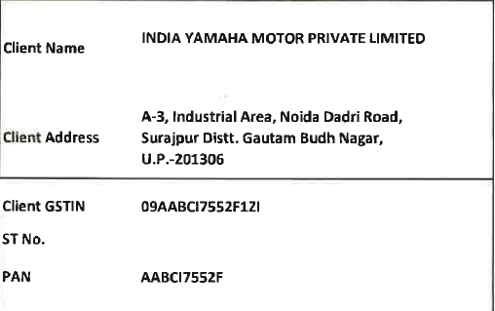

I have also attached a draft questionnaire for your perusal, kindly review the same, and update in format in which you are comfortable.

Please feel free to connect for any clarification.

Regards  
Anant

**From:** Prasenjit Saha <[prasenjit@market-xcel.com](mailto:prasenjit@market-xcel.com)>   
**Sent:** Tuesday, November 8, 2022 3:31 PM  
**To:** Anant Badhe <[abadhe@yamaha-motor-india.com](mailto:abadhe@yamaha-motor-india.com)>  
**Cc:** Kawada Takahiro <[kawadat@yamaha-motor.co.jp](mailto:kawadat@yamaha-motor.co.jp)>; [chandana.banerji@market-xcel.com](mailto:chandana.banerji@market-xcel.com); 'Vikram Gupta' <[vikram.gupta@market-xcel.com](mailto:vikram.gupta@market-xcel.com)>; [ashwani@market-xcel.com](mailto:ashwani@market-xcel.com); [manishoberoi@market-xcel.com](mailto:manishoberoi@market-xcel.com); [manish.ganvir@market-xcel.com](mailto:manish.ganvir@market-xcel.com)  
**Subject:** RE: Request for proposal - Study of The Call Of The Blue campaign

Dear Anant,

Thanks for your confirmation on MT15 Project.

The payment terms are acceptable to us. Kindly share the formal PO to initiate the study at our end.

Thanks & Regards

**Prasenjit Saha**

Project Director



**Market Xcel Data Matrix Pvt. Ltd.**

Extension: 551 / Direct Line: +91 11 42343 551 / Mobile: +91 9899765200

***Follow us on***

[](https://jpn01.safelinks.protection.outlook.com/?url=https%3A%2F%2Fwww.facebook.com%2Fmarketxceldatamatrix&data=05%7C01%7Cabadhe%40yamaha-motor-india.com%7C49d9158e8a5949cf6b3f08dacb9e2574%7C76684a67d81643ce93f929b6f72f823f%7C1%7C0%7C638046177399662520%7CUnknown%7CTWFpbGZsb3d8eyJWIjoiMC4wLjAwMDAiLCJQIjoiV2luMzIiLCJBTiI6Ik1haWwiLCJXVCI6Mn0%3D%7C3000%7C%7C%7C&sdata=XUwQdnWrmurxfdksfgUZfdfj87Iz3jFz2a9vDf6tHZY%3D&reserved=0)  [](https://jpn01.safelinks.protection.outlook.com/?url=https%3A%2F%2Ftwitter.com%2Fmarketxcel&data=05%7C01%7Cabadhe%40yamaha-motor-india.com%7C49d9158e8a5949cf6b3f08dacb9e2574%7C76684a67d81643ce93f929b6f72f823f%7C1%7C0%7C638046177399662520%7CUnknown%7CTWFpbGZsb3d8eyJWIjoiMC4wLjAwMDAiLCJQIjoiV2luMzIiLCJBTiI6Ik1haWwiLCJXVCI6Mn0%3D%7C3000%7C%7C%7C&sdata=ohQKzWaF2mnuc%2FiJdKQg2%2FZvB8hpArnYrrVDjvtNWPI%3D&reserved=0)  [](https://jpn01.safelinks.protection.outlook.com/?url=https%3A%2F%2Fwww.linkedin.com%2Fcompany%2Fmarket-xcel-data-matrix-pvt-ltd%3Ftrk%3Dtyah&data=05%7C01%7Cabadhe%40yamaha-motor-india.com%7C49d9158e8a5949cf6b3f08dacb9e2574%7C76684a67d81643ce93f929b6f72f823f%7C1%7C0%7C638046177399662520%7CUnknown%7CTWFpbGZsb3d8eyJWIjoiMC4wLjAwMDAiLCJQIjoiV2luMzIiLCJBTiI6Ik1haWwiLCJXVCI6Mn0%3D%7C3000%7C%7C%7C&sdata=0wc%2FQ0sunqi4G5hl3VSlbnSGJ0ZrovrY03innW%2FGlBw%3D&reserved=0)

**From:** Anant Badhe <[abadhe@yamaha-motor-india.com](mailto:abadhe@yamaha-motor-india.com)>   
**Sent:** 08 November 2022 15:23  
**To:** [prasenjit@market-xcel.com](mailto:prasenjit@market-xcel.com)  
**Cc:** Kawada Takahiro <[kawadat@yamaha-motor.co.jp](mailto:kawadat@yamaha-motor.co.jp)>; [chandana.banerji@market-xcel.com](mailto:chandana.banerji@market-xcel.com); [ashwani@market-xcel.com](mailto:ashwani@market-xcel.com); [manishoberoi@market-xcel.com](mailto:manishoberoi@market-xcel.com); [manish.ganvir@market-xcel.com](mailto:manish.ganvir@market-xcel.com)  
**Subject:** RE: Request for proposal - Study of The Call Of The Blue campaign

Dear Prasenjit,

Greetings!

Thank you for sharing the revised quote.

We will consider the same and revert as soon as we have decided on the project.

At the same time, as requested kindly confirm on the payment terms to be on completion of the project (will be applicable for this project as well) at the earliest and share the PI.

We can start working on the MT15 Project immediately.

Regards  
Anant

**From:** Prasenjit Saha <[prasenjit@market-xcel.com](mailto:prasenjit@market-xcel.com)>   
**Sent:** Tuesday, November 8, 2022 10:40 AM  
**To:** Anant Badhe <[abadhe@yamaha-motor-india.com](mailto:abadhe@yamaha-motor-india.com)>  
**Cc:** Kawada Takahiro <[kawadat@yamaha-motor.co.jp](mailto:kawadat@yamaha-motor.co.jp)>; [chandana.banerji@market-xcel.com](mailto:chandana.banerji@market-xcel.com); [ashwani@market-xcel.com](mailto:ashwani@market-xcel.com); [manishoberoi@market-xcel.com](mailto:manishoberoi@market-xcel.com); [manish.ganvir@market-xcel.com](mailto:manish.ganvir@market-xcel.com)  
**Subject:** RE: Request for proposal - Study of The Call Of The Blue campaign

Dear Anant,

Greetings!

Based on the past relationship we have relooked at the quotation for this study and are pleased to provide you our best quote for COBT study –

**INR 9,20,000** + GST

Look for a positive revert.

Thanks & Regards

**Prasenjit Saha**

Project Director



**Market Xcel Data Matrix Pvt. Ltd.**

Extension: 551 / Direct Line: +91 11 42343 551 / Mobile: +91 9899765200

***Follow us on***

[](https://jpn01.safelinks.protection.outlook.com/?url=https%3A%2F%2Fwww.facebook.com%2Fmarketxceldatamatrix&data=05%7C01%7Cabadhe%40yamaha-motor-india.com%7C49d9158e8a5949cf6b3f08dacb9e2574%7C76684a67d81643ce93f929b6f72f823f%7C1%7C0%7C638046177399662520%7CUnknown%7CTWFpbGZsb3d8eyJWIjoiMC4wLjAwMDAiLCJQIjoiV2luMzIiLCJBTiI6Ik1haWwiLCJXVCI6Mn0%3D%7C3000%7C%7C%7C&sdata=XUwQdnWrmurxfdksfgUZfdfj87Iz3jFz2a9vDf6tHZY%3D&reserved=0)  [](https://jpn01.safelinks.protection.outlook.com/?url=https%3A%2F%2Ftwitter.com%2Fmarketxcel&data=05%7C01%7Cabadhe%40yamaha-motor-india.com%7C49d9158e8a5949cf6b3f08dacb9e2574%7C76684a67d81643ce93f929b6f72f823f%7C1%7C0%7C638046177399662520%7CUnknown%7CTWFpbGZsb3d8eyJWIjoiMC4wLjAwMDAiLCJQIjoiV2luMzIiLCJBTiI6Ik1haWwiLCJXVCI6Mn0%3D%7C3000%7C%7C%7C&sdata=ohQKzWaF2mnuc%2FiJdKQg2%2FZvB8hpArnYrrVDjvtNWPI%3D&reserved=0)  [](https://jpn01.safelinks.protection.outlook.com/?url=https%3A%2F%2Fwww.linkedin.com%2Fcompany%2Fmarket-xcel-data-matrix-pvt-ltd%3Ftrk%3Dtyah&data=05%7C01%7Cabadhe%40yamaha-motor-india.com%7C49d9158e8a5949cf6b3f08dacb9e2574%7C76684a67d81643ce93f929b6f72f823f%7C1%7C0%7C638046177399662520%7CUnknown%7CTWFpbGZsb3d8eyJWIjoiMC4wLjAwMDAiLCJQIjoiV2luMzIiLCJBTiI6Ik1haWwiLCJXVCI6Mn0%3D%7C3000%7C%7C%7C&sdata=0wc%2FQ0sunqi4G5hl3VSlbnSGJ0ZrovrY03innW%2FGlBw%3D&reserved=0)

**From:** Prasenjit Saha <[prasenjit@market-xcel.com](mailto:prasenjit@market-xcel.com)>   
**Sent:** 27 October 2022 17:20  
**To:** 'Anant Badhe' <[abadhe@yamaha-motor-india.com](mailto:abadhe@yamaha-motor-india.com)>  
**Cc:** 'Kawada Takahiro' <[kawadat@yamaha-motor.co.jp](mailto:kawadat@yamaha-motor.co.jp)>; 'chandana.banerji@market-xcel.com' <[chandana.banerji@market-xcel.com](mailto:chandana.banerji@market-xcel.com)>; 'ashwani@market-xcel.com' <[ashwani@market-xcel.com](mailto:ashwani@market-xcel.com)>; 'manishoberoi@market-xcel.com' <[manishoberoi@market-xcel.com](mailto:manishoberoi@market-xcel.com)>; 'manish.ganvir@market-xcel.com' <[manish.ganvir@market-xcel.com](mailto:manish.ganvir@market-xcel.com)>  
**Subject:** RE: Request for proposal - Study of The Call Of The Blue campaign

Dear Anant,

Greetings!

Please find attached the proposal with respect to the Call of the Blue Campaign.

Kindly revert in case you seek any further clarification on the same.

Thanks & Regards

**Prasenjit Saha**

Project Director



**Market Xcel Data Matrix Pvt. Ltd.**

Extension: 551 / Direct Line: +91 11 42343 551 / Mobile: +91 9899765200

***Follow us on***

[](https://jpn01.safelinks.protection.outlook.com/?url=https%3A%2F%2Fwww.facebook.com%2Fmarketxceldatamatrix&data=05%7C01%7Cabadhe%40yamaha-motor-india.com%7C49d9158e8a5949cf6b3f08dacb9e2574%7C76684a67d81643ce93f929b6f72f823f%7C1%7C0%7C638046177399662520%7CUnknown%7CTWFpbGZsb3d8eyJWIjoiMC4wLjAwMDAiLCJQIjoiV2luMzIiLCJBTiI6Ik1haWwiLCJXVCI6Mn0%3D%7C3000%7C%7C%7C&sdata=XUwQdnWrmurxfdksfgUZfdfj87Iz3jFz2a9vDf6tHZY%3D&reserved=0)  [](https://jpn01.safelinks.protection.outlook.com/?url=https%3A%2F%2Ftwitter.com%2Fmarketxcel&data=05%7C01%7Cabadhe%40yamaha-motor-india.com%7C49d9158e8a5949cf6b3f08dacb9e2574%7C76684a67d81643ce93f929b6f72f823f%7C1%7C0%7C638046177399662520%7CUnknown%7CTWFpbGZsb3d8eyJWIjoiMC4wLjAwMDAiLCJQIjoiV2luMzIiLCJBTiI6Ik1haWwiLCJXVCI6Mn0%3D%7C3000%7C%7C%7C&sdata=ohQKzWaF2mnuc%2FiJdKQg2%2FZvB8hpArnYrrVDjvtNWPI%3D&reserved=0)  [](https://jpn01.safelinks.protection.outlook.com/?url=https%3A%2F%2Fwww.linkedin.com%2Fcompany%2Fmarket-xcel-data-matrix-pvt-ltd%3Ftrk%3Dtyah&data=05%7C01%7Cabadhe%40yamaha-motor-india.com%7C49d9158e8a5949cf6b3f08dacb9e2574%7C76684a67d81643ce93f929b6f72f823f%7C1%7C0%7C638046177399662520%7CUnknown%7CTWFpbGZsb3d8eyJWIjoiMC4wLjAwMDAiLCJQIjoiV2luMzIiLCJBTiI6Ik1haWwiLCJXVCI6Mn0%3D%7C3000%7C%7C%7C&sdata=0wc%2FQ0sunqi4G5hl3VSlbnSGJ0ZrovrY03innW%2FGlBw%3D&reserved=0)

**From:** Manish Oberoi <[manishoberoi@market-xcel.com](mailto:manishoberoi@market-xcel.com)>   
**Sent:** 20 October 2022 18:07  
**To:** 'Anant Badhe' <[abadhe@yamaha-motor-india.com](mailto:abadhe@yamaha-motor-india.com)>  
**Cc:** 'Kawada Takahiro' <[kawadat@yamaha-motor.co.jp](mailto:kawadat@yamaha-motor.co.jp)>; 'RFP@' <[rfp@market-xcel.com](mailto:rfp@market-xcel.com)>; [chandana.banerji@market-xcel.com](mailto:chandana.banerji@market-xcel.com); [prasenjit@market-xcel.com](mailto:prasenjit@market-xcel.com); [ashwani@market-xcel.com](mailto:ashwani@market-xcel.com); [manish.ganvir@market-xcel.com](mailto:manish.ganvir@market-xcel.com)  
**Subject:** RE: Request for proposal - Study of The Call Of The Blue campaign   
**Importance:** High

Dear Anant,

Thank you for the confirmation.

We shall work around the given scope and get back to you with our feasibility and cost in accordance.

Thanks & Regards

**Manish Oberoi**

Sr. Manager – Client Services



**Market Xcel Data Matrix Pvt. Ltd.**

Extension: 505 / Direct Line: +91 11 42343 505 / Mobile: +91 9958 234 888

***Follow us on***

[](https://jpn01.safelinks.protection.outlook.com/?url=https%3A%2F%2Fwww.facebook.com%2Fmarketxceldatamatrix&data=05%7C01%7Cabadhe%40yamaha-motor-india.com%7C49d9158e8a5949cf6b3f08dacb9e2574%7C76684a67d81643ce93f929b6f72f823f%7C1%7C0%7C638046177399662520%7CUnknown%7CTWFpbGZsb3d8eyJWIjoiMC4wLjAwMDAiLCJQIjoiV2luMzIiLCJBTiI6Ik1haWwiLCJXVCI6Mn0%3D%7C3000%7C%7C%7C&sdata=XUwQdnWrmurxfdksfgUZfdfj87Iz3jFz2a9vDf6tHZY%3D&reserved=0)  [](https://jpn01.safelinks.protection.outlook.com/?url=https%3A%2F%2Ftwitter.com%2Fmarketxcel&data=05%7C01%7Cabadhe%40yamaha-motor-india.com%7C49d9158e8a5949cf6b3f08dacb9e2574%7C76684a67d81643ce93f929b6f72f823f%7C1%7C0%7C638046177399662520%7CUnknown%7CTWFpbGZsb3d8eyJWIjoiMC4wLjAwMDAiLCJQIjoiV2luMzIiLCJBTiI6Ik1haWwiLCJXVCI6Mn0%3D%7C3000%7C%7C%7C&sdata=ohQKzWaF2mnuc%2FiJdKQg2%2FZvB8hpArnYrrVDjvtNWPI%3D&reserved=0)  [](https://jpn01.safelinks.protection.outlook.com/?url=https%3A%2F%2Fwww.linkedin.com%2Fcompany%2Fmarket-xcel-data-matrix-pvt-ltd%3Ftrk%3Dtyah&data=05%7C01%7Cabadhe%40yamaha-motor-india.com%7C49d9158e8a5949cf6b3f08dacb9e2574%7C76684a67d81643ce93f929b6f72f823f%7C1%7C0%7C638046177399662520%7CUnknown%7CTWFpbGZsb3d8eyJWIjoiMC4wLjAwMDAiLCJQIjoiV2luMzIiLCJBTiI6Ik1haWwiLCJXVCI6Mn0%3D%7C3000%7C%7C%7C&sdata=0wc%2FQ0sunqi4G5hl3VSlbnSGJ0ZrovrY03innW%2FGlBw%3D&reserved=0)

**From:** Anant Badhe <[abadhe@yamaha-motor-india.com](mailto:abadhe@yamaha-motor-india.com)>   
**Sent:** 20 October 2022 18:03  
**To:** [manishoberoi@market-xcel.com](mailto:manishoberoi@market-xcel.com)  
**Cc:** Kawada Takahiro <[kawadat@yamaha-motor.co.jp](mailto:kawadat@yamaha-motor.co.jp)>; 'RFP@' <[rfp@market-xcel.com](mailto:rfp@market-xcel.com)>  
**Subject:** RE: Request for proposal - Study of The Call Of The Blue campaign

Hi Manish.

We are looking for end to end support.

Regards  
Anant

**From:** Manish Oberoi <[manishoberoi@market-xcel.com](mailto:manishoberoi@market-xcel.com)>   
**Sent:** Thursday, October 20, 2022 6:03 PM  
**To:** Anant Badhe <[abadhe@yamaha-motor-india.com](mailto:abadhe@yamaha-motor-india.com)>  
**Cc:** Kawada Takahiro <[kawadat@yamaha-motor.co.jp](mailto:kawadat@yamaha-motor.co.jp)>; 'RFP@' <[rfp@market-xcel.com](mailto:rfp@market-xcel.com)>  
**Subject:** RE: Request for proposal - Study of The Call Of The Blue campaign   
**Importance:** High

Dear Anant,

Greetings for the day! Wishing you and everyone a Happy Diwali as well😊

The shared brief is well received just a quick check you want end to end support for this or just data collection so that we can work around accordingly and get back to you.

Thanks & Regards

**Manish Oberoi**

Sr. Manager – Client Services



**Market Xcel Data Matrix Pvt. Ltd.**

Extension: 505 / Direct Line: +91 11 42343 505 / Mobile: +91 9958 234 888

***Follow us on***

[](https://jpn01.safelinks.protection.outlook.com/?url=https%3A%2F%2Fwww.facebook.com%2Fmarketxceldatamatrix&data=05%7C01%7Cabadhe%40yamaha-motor-india.com%7C49d9158e8a5949cf6b3f08dacb9e2574%7C76684a67d81643ce93f929b6f72f823f%7C1%7C0%7C638046177399662520%7CUnknown%7CTWFpbGZsb3d8eyJWIjoiMC4wLjAwMDAiLCJQIjoiV2luMzIiLCJBTiI6Ik1haWwiLCJXVCI6Mn0%3D%7C3000%7C%7C%7C&sdata=XUwQdnWrmurxfdksfgUZfdfj87Iz3jFz2a9vDf6tHZY%3D&reserved=0)  [](https://jpn01.safelinks.protection.outlook.com/?url=https%3A%2F%2Ftwitter.com%2Fmarketxcel&data=05%7C01%7Cabadhe%40yamaha-motor-india.com%7C49d9158e8a5949cf6b3f08dacb9e2574%7C76684a67d81643ce93f929b6f72f823f%7C1%7C0%7C638046177399818758%7CUnknown%7CTWFpbGZsb3d8eyJWIjoiMC4wLjAwMDAiLCJQIjoiV2luMzIiLCJBTiI6Ik1haWwiLCJXVCI6Mn0%3D%7C3000%7C%7C%7C&sdata=KkRMfYaWVJrSDhsJtKIn3%2BYbCv2Wv6R11nef4grrD3s%3D&reserved=0)  [](https://jpn01.safelinks.protection.outlook.com/?url=https%3A%2F%2Fwww.linkedin.com%2Fcompany%2Fmarket-xcel-data-matrix-pvt-ltd%3Ftrk%3Dtyah&data=05%7C01%7Cabadhe%40yamaha-motor-india.com%7C49d9158e8a5949cf6b3f08dacb9e2574%7C76684a67d81643ce93f929b6f72f823f%7C1%7C0%7C638046177399818758%7CUnknown%7CTWFpbGZsb3d8eyJWIjoiMC4wLjAwMDAiLCJQIjoiV2luMzIiLCJBTiI6Ik1haWwiLCJXVCI6Mn0%3D%7C3000%7C%7C%7C&sdata=atj7TUH0COviVl1GptWsi5p6jT5Jaxdlvh2IT184OkU%3D&reserved=0)

**From:** Anant Badhe <[abadhe@yamaha-motor-india.com](mailto:abadhe@yamaha-motor-india.com)>   
**Sent:** 20 October 2022 17:58  
**To:** [manishoberoi@market-xcel.com](mailto:manishoberoi@market-xcel.com)  
**Cc:** Kawada Takahiro <[kawadat@yamaha-motor.co.jp](mailto:kawadat@yamaha-motor.co.jp)>  
**Subject:** Request for proposal - Study of The Call Of The Blue campaign

Dear Manish San,

Greetings for the day and Happy Diwali in advance

We want to conduct a study to understand the awareness and effectiveness of The Call Of The Blue campaign with the target group in 20 cities.

I am attaching a brief for the study, Please check, and share the proposal

Please feel free to connect for any query.

Regards

Anant Badhe

7722002627