Invoice

Kind Attention Invoice Date21-9-24

17, Okhla Industrial Estate Phase 3 Rd, Okhla Phase III,

Okhla Industrial Estate, New Delhi, Delhi 110020

Market excel

Project name –F2F IDI,s @home

Visit coffee

Project no-20240945

Centre: Delhi

|  |  |  |  |
| --- | --- | --- | --- |
| Sr. No. | Particular | Rate | Amount |
|  | Moderation @ 2500 per DI  Conveyance charges | 2500*6 | 15000  114 |
|  | Total— |  | 15114 |
| Amount In Words-fifteenthousand one hundred and fourteen rupees only | | | |

Name: Shubhangi Sharma

Address: A-211, Hari Nagar, Clock Tower,

New Delhi (110064)

Mobile No.: 8287508246

PAN No.: RMFPS7707L

**Bank Account Details**

Beneficiary Name : Shubhangi Sharma

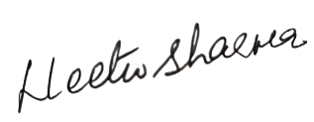Account Number: 110045237087

IFSC Code: CNRB0003160

Bank Name and Address Canara bank B -234 , Hari Nagar

New Delhi 110064 Signature