Bill of Supply
(GST Non- Register)

Vendor Name  Vendor Address  Vendor Contact No.  Vendor Pan No.  Vendor E-mail ID | Sapna Chawla  No.6,4th Cross, Sindhi Colony, Assaye road, Bangalore 560005  9886019985  AFIPC0244B  sapnachawla@live.com
Invoice Date – 09/04/25  Invoice No – 07  Project Name – AI March 2025  Project No - 20250360 |  | Billing to:  Market Xcel Data Matrix Pvt Ltd  No.135, Oblique 1, 2nd Floor,  Lal Bagh Road, Old Mission Compound,  Opp Garuda Maruthi Show room  Bangalore - 560027

S. No. | Date | Description of the Service |  | Category Type | No. of Units/Mins. & Duration | Per Unit Price | Total Amount (₹)
1 | 07/04/25 | Translation |  | FGD | MANDAY | 8000 | 8000
2 | 08/04/25 | Translation |  | DI |  |  | 8000
 |  |  | Grand Total (₹) |  |  |  | 16000

Grand Total in Words (Rupees): Sixteen thousand only/-

Beneficiary Name: - Sapna S Chawla
Bank Name: - Karnataka Bank
Bank Account No.: -4842500102689001
Bank IFSC Code: - KARB0000571
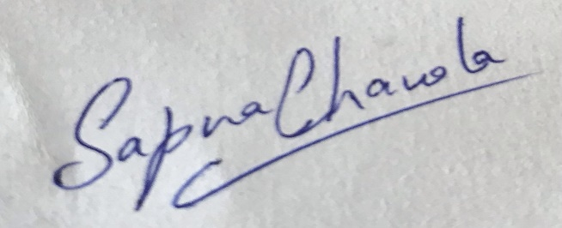

(Signature)

