Invoice

Kind Attention Date-21-9-24

KRISHNA GOUR

MARKET-XCEL

Project name – cognitive interview

study

JOB NO- 20240808

Centre: DELHI and MEERUT

|  |  |  |  |
| --- | --- | --- | --- |
| Sr. No. | Particular | Rate | Amount |
|  | Moderation @ 10000 Manday basis (DELHI)  Moderation @ 12000 Manday basis (MEERUT)  EXCEL SHEET charges @ 1000 per sheet  Total conveyance of dates 11 and 12 September  Food charges on 12 September | 10000  12000  8000  1291  560 |  |
|  | Total— | 31,851 |  |
| Amount In Words-Thirty one thousand eight hundred and fifty one rupees only. | | | |

Name: Neetu Sharma

Address: A-211, Hari Nagar, Clock Tower,

New Delhi (110064)

Mobile No.: 8810455919

PAN No.: DCFPS6631M

**Bank Account Details**

Beneficiary Name : Shubhangi Sharma

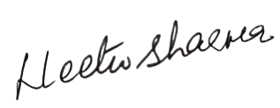Account Number: 110045237087

IFSC Code: CNRB0003160

Bank Name and Address Canara bank B 234,Hari Nagar

New Delhi 110064 Signature