Bill of Supply
(GST Non- Register)

Vendor Name  Vendor Address  Vendor Contact No.  Vendor Pan No.  Vendor E-mail ID | Sapna Chawla  No.6,4th Cross, Sindhi Colony, Assaye road, Bangalore 560005  9886019985  AFIPC0244B  sapnachawla@live.com
Invoice Date – 31/01/25  Invoice No – 06  Project Name - Akira  Project No - 20250150 |  | Billing to:  Market Xcel Data Matrix Pvt Ltd  No.135, Oblique 1, 2nd Floor,  Lal Bagh Road, Old Mission Compound,  Opp Garuda Maruthi Show room  Bangalore - 560027

S. No. | Date | Description of the Service |  | Category Type | No. of Units/Mins. & Duration | Per Unit Price | Total Amount (₹)
1 | 31/01/25 | Report Making |  |  | 1 | 8000 | 8000
 |  |  | Grand Total (₹) |  |  |  | 8000

Grand Total in Words (Rupees): Eight thousand only/-

Beneficiary Name: - Sapna S Chawla
Bank Name: - Karnataka Bank
Bank Account No.: -4842500102689001
Bank IFSC Code: - KARB0000571
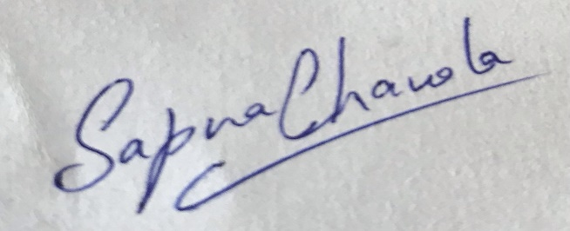

(Signature)

