INVOICE
Name: Bhairu Vithoba Patil
Address: A/2/1 Shreeyash Apts, 597 Narayan Peth, Kelkar Road, Pune, Maharashtra -411030
Mobile No. 9860331859 | PAN: AIWPP4723B
Invoice Date: 06/06/2024 | Invoice No.: 02
BILL TO | Job No:  Job Name: Swades Assessment Raigad
Market Xcel Data Matrix Private Limited
17 Okhla Industrial Estate, Phase 3 Road, Phase 3
New Delhi-110020
SERVICE DESCRIPTION | AMOUNT
Field Coordinator - Data Collection Work
Consultancy Fee | ₹.70000
TOTAL | ₹.70000
Amount in Words | Seventy Thousand Only
BANK DETAILS
Account in the name of – BHAIRU V. PATIL
Account No -07210110012920
IFSC –KKBK0000721
Bank Name-KOTAK MAHINDRA BANK
Bank Branch-EAST STREET, PUNE 411001
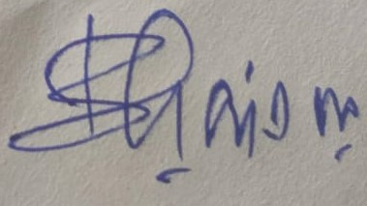 | Manager Signature
Vendor Signature | Approved By
THANK YOU FOR YOUR BUSINESS!

