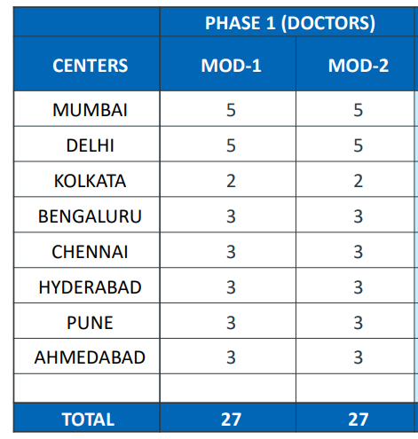              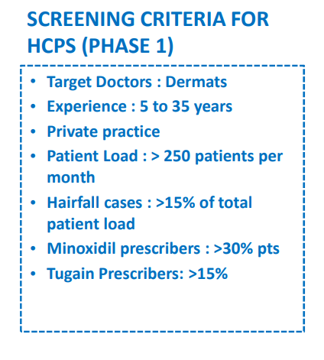

**Kindly provide us with your quotes in the format below:**

|  |  |  |
| --- | --- | --- |
| **Study Background/ Objectives** | **:** | MINOXIDIL POSITIONING AND BRAND PERCEPTION MAPPING |
| **Methodology** | **:** | Qualitative |
| **Type of Service Required** | **:** | Recruitment of HCPs |
| **Target Respondent(s)** | **:** | HCPs |
| **Sample Size/ Unit/ Volume** | **:** | 34 |
| **Length of Interview (LOI)** | **:** | Upto 45 mins |
| **Work Commencing Date** | **:** | 23rd October |