Bill of Supply
(GST Non- Register)

Name  Address  Mobile No  Pan No  E-mail ID | Srini N  2-2-647/77/G25 SBI Officers Colony; Hyderabad, Telangana State, Hyd-13  7989096677  BSXPN8885L  srininalamati1998@gmail.com
Invoice Date – 01/03/2024  Job no- 20231252  Job name: Skye Jasmine Soap |  | Billing To,  Market Xcel Data Matrix Pvt Ltd (H.O)  GROUND FLOOR 17 OKHLA INDUSTRIAL ESTATE PHASE 3 DELHI  GSTIN : 07AAECM5086D1ZI

S. No. | Description | IDI/  FGD/  MGD/  Workshop | Activity/  Unit/  Qty/  Mins | Per Unit Rate (Rs.) | Total Amount (Rs.)
1. | Lux Jasmine Study-FGD2-Bangalore-2.30pm |  | 56min | 18 | 1008
2. | Lux Jasmine Study-FGD-Bangalore |  | 65 mins | 18 | 1170
5.
 | Total |  |  |  | 2178

Total in Words: TWO THOUSAND ONE HUNDRED AND SEVENTY EIGHT ONLY

Beneficiary Name: - SRINI N
Bank Name: - CANARA BANK
Bank Account No.: - 6725101000598
Bank Account Type: - Savings Account
Bank IFSC Code: - CNRB0006725
Bank Branch Adds: - DD COLONY, HYDERABAD
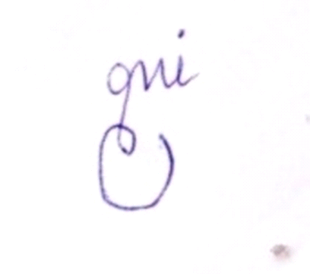
(Signature)

