***ARCHANA KOCHAR***

***437, CLERK COLONY***

***PARDESHIPURA***

***INDORE (452001)***

***(07898343810)***

**PAN NO : EFEPK0047G**

**Bill no: 001/2025**

**Date: 23/01/2025**

**Project name: Pr Wonder 2 Indore**

**Project number : 20250124**

**Centre: Indore**

**To,**

**Market Xcel Data Matrix Pvt Ltd**

**INVOICE**

|  |  |  |  |
| --- | --- | --- | --- |
| **PARTICULARS** | **No. of Units** | **Rate per Unite** | **AMOUNT**  **IN INR** |
| **Performing moderation**   1. **Dis** | **24** | **1500** | **36000/-** |
| **Total** |  |  | **36000/-** |

**(Rupees MENTION AMOUNT)**

**INR in Words: - Thirtysix thousand rupees only**

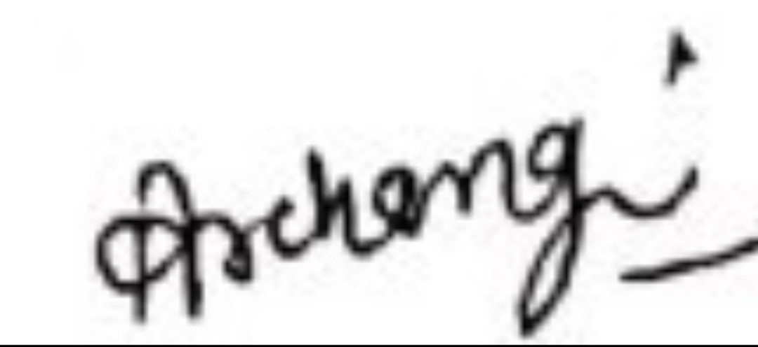

**ARCHANA KOCHAR**

**Name & Signature**

**Bank Details through NEFT**

**Beneficiary's Name : ARCHANA KOCHAR**

**Bank : PUNJAB NATIONAL BANK**

**Account Number : 2892000109081536**

**BRANCH : AB ROAD**

**IFSC CODE : PUNB0289200**