RAJESH MANAK |  | Invoice No. 542/24-25 | Dated : 19/04/2024
271 Jheel, P.O. Krishna Nagar, Delhi-110051 |  | BUYER/RECEIVER :Mkt. Xcel D M Pvt. Ltd.
GSTIN/UIN : 07ANCPM9177H1ZM |  | 17 Okhla Ind. Est., Ph.-3
E-mail : raj.manak@gmail.com |  | N Delhi-110020
Mob No. : 9999975090/8860775995 (res.) |  | GSTIN- 07AAECM5086D1ZI
Project  Name/No. | Opinion @Delhi  202412119 | HSN/SAC | RATE | AMOUNT
1. | Mid.- 2 Ext FGDs (20th Mar. ’25) | 998371 | 4,000 | 8,000/-
2. | Exp. – (Non Taxable) |  |  | 500/-
Rupees in Words: Nine Thousand Nine Hundred & Forty Only |  | Total Amount before GST |  | 8,500/-
 |  | Add : SGST………9% |  | 720/-
 |  | Add : CGST………9% |  | 720/-
PAN : ANCPM9177H |  | Add : IGST………..%
BANK DETAILS |  | Total GST |  | 1,440/-
State Bank Of India |  | Total Amount |  | 9,940/-
A/c No. : 38056208323
IFSC : SBIN0040632
Branch : JHEEL Chowk, Gandhi Nagar, Delhi-31 |  | 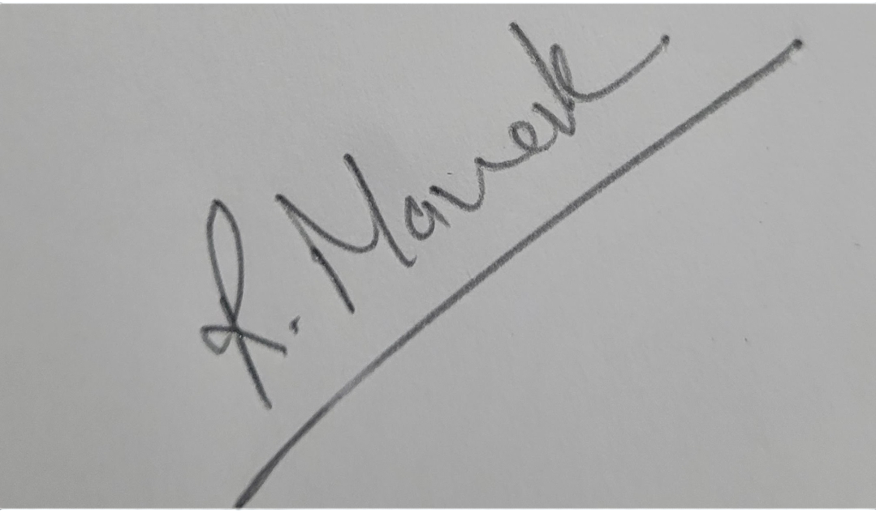
E.&O.E. |  | AUTHORISED SIGNATORY

