INVOICE
Name: Annasaheb Suresh Dolare
Address: 648/6 Plot No., H21, New Padmawati Nagar, Bibwewadi, Opp. Upper Bus Stand, Pune Maharashtra -411037
Mobile No. 9850980525 | PAN: AJEPD1920H
Invoice Date: 10/06/2024 | Invoice No.: 02
BILL TO | Job No: 202402115  Job Name: Impact Assessment Swades Model Village
Market Xcel Data Matrix Private Limited
17 Okhla Industrial Estate, Phase 3 Road, Phase 3
New Delhi-110020
SERVICE DESCRIPTION | AMOUNT
Field Coordinator - Data Collection Work
Translation & Transcription Charges | ₹ 55000
TOTAL | ₹55000
Amount in Words | Fifty-Five Thousand Only
BANK DETAILS
Account in the name of – ANNASAHEB SURESH DOLARE
Account No -1302104000058946
IFSC –IBKL0001302
Bank Name-IDBI BANK
Bank Branch-BIBWEWADI, PUNE 411037
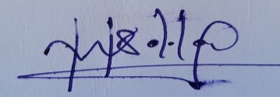 | Manager Signature
Vendor Signature | Approved By
THANK YOU FOR YOUR BUSINESS!

