INVOICE

Name - Surbhi soni
Address: - 95 sai gangotri vihar, Indore 452002
Contact Details - +91 8109027770

Date: 10/04/2024
To,
Market Xcel Data Matrix Pvt Ltd.
17, Okhla Industrial Estate Phase 3 Rd,
Okhla Phase III, Okhla Industrial Estate,
New Delhi, Delhi 110020
Bill Number: 003
Project Name | Project Number | Details | Rate | Amount
Consumer Persona Research Requirement | 20240526 | Moderation | 4 Manday | 40,000/-

Amount in words: Forty Thousand Only/-
Surbhi soni
sai gangotri vihar, Indore 452002

Bank Acct #: - 20380803888
STATE BANK OF INDIA.
Name: - SURBHI SONI
IFSC: - SBIN0030015
Branch: - SBI BANK

For
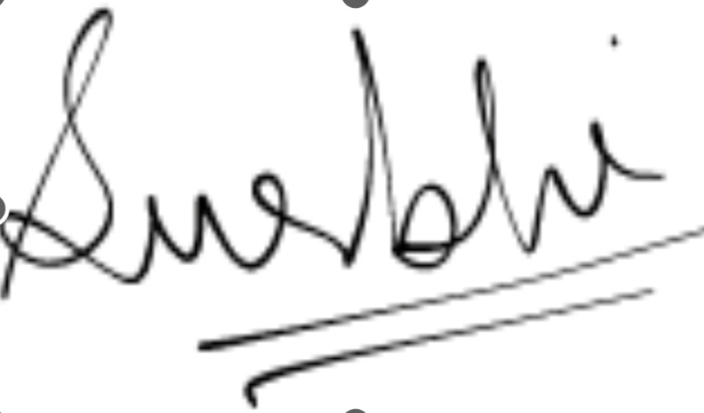
SURBHI SONI

