Sangeeta Sathe

Bill No:296/2024-25 Name : Sangeeta Sathe

Address: 301, C Nav Asavari
J.B. Nagar
Andheri (E)
Mumbai-59
Date: 9th October 2024

To,
Market Xcel
S2 Pinnacle Business park,
Mahakali caves road, Santi Nagar
Andheri east
Mumbai RE: Project: Care Network

JOB No: 20240923

Towards Translation of 2 Triads @ 3,500 per Triad = 7,000 Rs

Total = 7,000 Rs

In words: (Seven thousand, only)

PAN Card No: = ANQPS5939R
Bank details: JANAKALYAN SAHAKARI BANK LIMITED
ANDHERI EAST
RTGS (IFSC): JSBL0000010
A/C No: 010010100013843

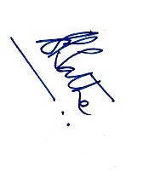 Signature:

Name: Sangeeta Sathe.

