RUDRANI CHATTERJEE

TARULIA 3RD LANE, KRISHNAPUR, P.S- NETWOWN

KOLKATA – 700102

**Pan Card no. ARRPC7079H**

**INVOICE**

INVOICE NO DATE

RC-003 02.09.2024

To,

Market Xcel Data Matrix Pvt Ltd.

P36, Gariahat Road (South)

Kolkata – 700 031

SL NO. DESCRIPTION QNTY UNIT AMOUNT

PRICE

Rs . P

Project – RFQ Qual Diwali

Job no.20240868

Centre – Kolkata

-------------------------------------------------------

1. DI Interpretation 1 5000 5000 00

.

------------------------------------------------------------------------------------------------------------------------------------------------------

**Total ₹ 5,000 00**

**TOTAL Rupees** – **Five Thousand only**

Bank det ails: E. &O.E **ICICI BANK** 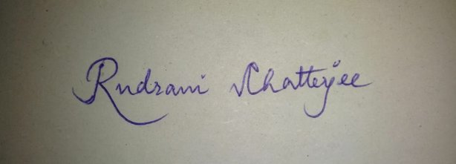

**Kestopur Branch**

**A/C no. 130101508235**

**IFSC Code: ICIC0003307 RUDRANI CHATTERJEE**



RUDRANI CHATTERJEE

E & O E

t